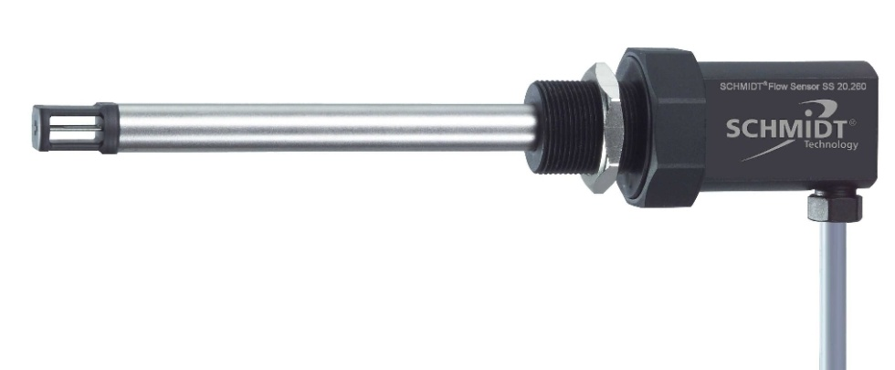
SCHMIDT® Flow Sensor
SCHMIDT® Flow Sensor
SS 20.260
Instructions for Use

SS 20.260

Table of Contents

1 Important information 3
2 Application range 4
3 Mounting instructions 4
4 Electrical connection 11
5 Signalization 12
6 Startup 14
7 Information concerning operation 15
8 Service information 16
9 Technical data 17
10 EC Declaration of conformity 18

Imprint:
Copyright 2011 SCHMIDT Technology GmbH
All rights reserved

Version 508981.02E
Subject to modifications

Important information
The instructions for use contain all required information for a fast commissioning and a safe operation of the SCHMIDT® flow sensor SS 20.260:
- These instructions for use must be read completely and observed carefully, before putting the unit into operation.
- Any claims under the manufacturer's liability for damage resulting from non-observance or non-compliance with these instructions will become void.
- Tampering with the device in any way whatsoever - with the exception of the designated use and the operations described in these instructions for use - will forfeit any warranty and exclude any liability.
- The unit is designed exclusively for the use described below (see chapter 2). In particular, it is not designed for direct or indirect personal protection.
- SCHMIDT Technology cannot give any warranty as to its suitability for certain purpose and cannot be held liable for accidental or sequential damage in connection with the delivery, performance or use of this unit.

Symbols used in this manual
The symbols used in this manual are explained in the following section.

Danger warnings and safety instructions – read them carefully!
Non-observance of these instructions may lead to injury of personnel or malfunction of the device.

General note
All dimensions are indicated in mm.

Application range
The SCHMIDT® flow sensor SS 20.260 is designed for stationary measurement of the flow velocity as well as the temperature of air and gases under atmospheric pressure.
The sensor is based on the measuring principle of the thermal anemometer and measures the mass flow of the measuring medium as flow velocity which is output in a linear way as standard velocity w_{N} (unit: m/s), based on standard conditions of 1013.25 hPa and 20 °C. Thus, the resulting output signal is independent from the pressure and temperature of the medium to be measured.
The SCHMIDT® flow sensor SS 20.260 is designed for the use inside closed rooms and is not suitable for outdoor use.

Mounting instructions

General information on handling
The SS 20.260 is a precision instrument with high measuring sensitivity. In spite of the robust construction of the sensor tip soiling of the inner sensor elements can lead to distortion of measurement results (see also chapter 8 Service information). During procedures that could stimulate soiling like transport, mounting or dismounting of the sensor it is recommended to place the enclosed SCHMIDT Technology protective cap on the sensor tip and remove it only during operation.
During processes with enhanced risks of soiling such as transport or mounting the protective cap should be placed onto the sensor tip.

General installation conditions
The sensor measures the flow speed correctly only in the direction given on the housing and sensor head (arrow). Make sure that the sensor is adjusted in flow direction; a tilting of up to ±3° is allowed.
The sensor measures unidirectional and must be adjusted correctly relative to the flow direction.
A sensor mounted in opposite direction of the flow direction leads to wrong measuring values (too high).
The lower measuring range limit is according to the system requirements 0.2 m/s.

At lower flow velocities (< 2 m/s) the measured medium temperature is too high.
The center of the chamber head is the actual measuring point of the flow measurement and must be placed in the flow as advantageous as possible, for example in the middle of a pipe (see Figure 1). Therefore this point is also used for specification of probe length L (see Figure 2).
Direction of measurement
Flow
Figure 1 Positioning in a pipe
In closed systems the sensor head must be located in the center of the pipe.

Installation with low disturbance
Local turbulences of the medium can cause distortion of measurement results. Therefore, appropriate mounting conditions must be guaranteed to ensure that the gas flow is supplied to the sensor in a quiet and low in turbulence state in order to maintain the accuracy specified (see chapter 9 Technical data).
Correct measurements require quiet flow, as low-turbulence as possible.
An undisturbed flow profile can be achieved if a sufficiently long distance in front of (run-in distance) and behind (run-out distance) the sensor installation site (see Figure 2) is held absolutely straight and without disturbances (such as edges, seams, bends etc.). It is also necessary to pay attention to the design of the run-out distance because disturbances also generate turbulences against the flow direction.

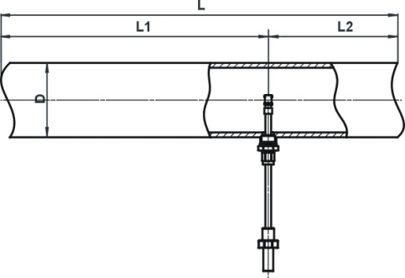 | L | = Length of entire measuring distance
 | L1 | = Length of run-in distance
 | L2 | = Length of run-out distance
 | D | = Inner diameter of measuring distance
Figure 2
The following Table 1 shows the required straight conduit lengths depending on the pipe inner diameter “D” and the different disturbance causes.
Flow obstacle upstream of the measuring distance | Minimum length of L1 | Minimum length of L2
Light bend (< 90°) | 10 x D | 5 x D
Reduction / expansion / 90° bend or T-junction | 15 x D | 5 x D
Two 90° bends in one plane (2-dimensional) | 20 x D | 5 x D
Two 90° bends (3-dimensional change in direction) | 35 x D | 5 x D
Shut-off valve | 45 x D | 5 x D
Table 1
This table lists the minimum values required in each case. If the listed straight conduit lengths cannot be achieved, measurement accuracy may be impaired.
Calculation of volume flow
If the cross section area of the pipe is known, the output signal of the flow speed can be used to calculate the standard volumetric flow of the medium. By means of a correction factor PF, which depends on the pipe diameter the measured value can be converted to an averaged flow w_{N} which is constant over the whole pipe cross-section.
Thus, it is possible to calculate the standard volumetric flow of the medium using the measured standard flow velocity in a pipe with known inner diameter:
D | Inner diameter of pipe [m]
A | Cross-section area of pipe [m²]
 | Flow velocity in the middle of the pipe [m/s]
 | Average flow velocity in the pipe [m/s]
PF | Profile factor (for pipes with circular cross-sections)
EF | Measuring unit factor (conversion to non-SI units)
 | Standard volumetric flow [m³/s]

Table 2 lists profile factors and volume flow measuring ranges (with certain sensor measuring ranges) for standard pipe diameters.
Table 2

The measuring unit factor EF serves only for convenient conversion to non-SI measuring units, for example m³/h (see Table 3).
 |  | Measuring unit of diameter D
 | EF | m | cm | mm
Measuring unit  volumetric flow | m³/s | 1 | 1,0E-04 | 1,0E-06
Measuring unit  volumetric flow | m³/min | 60 | 6,0E-03 | 6,0E-05
Measuring unit  volumetric flow | m³/h | 3600 | 3,6E-01 | 3,6E-03
Measuring unit  volumetric flow | l/s | 1000 | 1,0E-01 | 1,0E-03
Measuring unit  volumetric flow | l/min | 6,0E+04 | 6 | 0,06
Measuring unit  volumetric flow | l/h | 3,6E+06 | 360 | 3,6
Table 3
SCHMIDT Technology provides a convenient calculation tool to compute flow velocity or volume flow in pipes for all its sensor types and measuring ranges. This “Flow Calculator” can be directly used on or downloaded from SCHMIDT homepage:
http://www.schmidttechnology.de/de/sensorik/download/FlowCalculator.zip

Mounting in a walll
The housing has an external thread M18 x 1 (19 mm long) for direct mounting on or in the medium separating wall. Its advantage is in the simplicity of installation without special accessories; however, the immersion depth is defined by the probe length in this case and requires access from both sides for operation.
- Drill a bore in the wall with 13 … 14 mm diameter.
- Carefully insert measuring probe with an attached protection sleeve into the bore so that the mounting block of the enclosure is in contact with the wall.
- Screw on the enclosed fastening nut by hand on the medium side, turn sensor into required position and tighten fastening nut (SW22) while holding up the enclosure on the mounting block by means of SW30.
Angular deviation should not be greater than ± 3° relative to ideal position.

- Check the set angular position carefully, for example by means of a spirit level at the hexagonal part of the sensor enclosure.
- Finally, remove protective cap from sensor tip.

Mounting with a compression fitting
The sensor is installed using a special compression fitting. Normally, a sleeve is welded as a connecting piece onto a bore in the medium-guiding pipe, in which the external thread (G½) of the compression fitting is screwed (see Figure 3).
MID = 20

Figure 3
 | L |  | Probe length [mm]
 | SL |  | Length of weld-in sleeve [mm]
 | AL |  | Projecting length [mm]
 | D_{A} |  | Outer diameter of pipe [mm]
 | MID |  | Minimum immersion depth [mm]
 | E |  | Setting length of probe [mm]
- Bore a mounting opening in a pipe wall.
- Weld connecting piece with an internal thread G½ in the center above the mounting opening on the pipe.
Recommended length of connecting piece: 15 ... 40 mm
- If necessary wrap thread using a common sealing tape, for example made of PTFE.
- Screw threaded part of compression fitting one or two turns by hand into connecting piece then tighten it with a screw wrench (SW27).
- Remove compression fitting nut and extract both poetry halves.
- Remove protective cap from sensor tip and attach compression fitting nut on sensor probe.
- Insert probe in threaded part of the compression fitting, attach poetry halves and screw on fitting nut manually to such an extent that sensor probe can be inserted without jamming.
- In case of a longer sensor probe push it partly into the pipe as required.
Always avoid bending of the probe during screwing.

- Carefully slide probe so that the center of the chamber head is placed at the optimum measuring position in the middle of the pipe.
- Tighten compression fitting nut slightly by hand so that sensor is fixed.
- Turn sensor manually at its enclosure into required direction and precise position while maintaining immersion depth.
Angular deviation should not be greater than ± 3° relative to ideal position.

- Hold sensor and tighten compression fitting nut by turning the fork wrench (SW17) a quarter of a turn.
Recommended torque: 10 … 15 Nm
- Check the set angular position carefully, for example by means of a spirit level at the hexagonal part of the sensor enclosure.
Mounting accessories
Type / article No. | Drawing | Mounting
Clamp  a.) 524 916  b.) 524 882 |  | - Internal thread G½  - Material:  a.) Steel, black  b.) Stainless steel 1.4571
Compression fitting  Brass  517 206 |  | - Immersion sensor  - Pipe (typ.), wall  - Screwing into a welding stud  - Material:  Brass  PTFE, NBR  Atmospheric pressure use!
Table 4

Electrical connection
During electrical installation ensure that no voltage is applied and inadvertent activation is not possible.
The sensor is electrically connected according to Table 5 by means of the open cable ends of a 4-wire cable firmly fixed to the sensor housing.
Wire color | Designation | Function
Brown (BR) | Power | Operating voltage: +U_{B}
White (WH) | GND | Operating voltage: Mass
Yellow (YE) | Analog w_{N} | Output signal: Flow velocity
Green (GR) | Analog T_{M}  or  AGND | Output signal: Temperature of the medium  or  Ground connection of analog output
Table 5

Operating voltage
For proper operation the sensor requires DC voltage with a nominal value of 24 V with permitted tolerance of ±10 % and the sensor is protected against a polarity reversal.
Deviating values lead to deactivation of the measuring function or even to failure. As far as it is possible, the LED indication as well as both analog outputs report faulty operational conditions (see chapter 5 Signalization).
Only operate sensor within the defined range of operating voltage (24 V DC ± 10 %). Undervoltage may result in malfunction. Overvoltage may lead to irreversible damage to the sensor.

Wiring of analog outputs
The analog output of the basic variant of the sensor (“-1”), which measures only flow velocity, is alternatively (order option) of the type tension (0 … 10 V) or laid-out as current interface (4 … 20 mA). The enhanced version (“-2”) with an additional analog output for signalizing the temperature of the medium comes with 2 current interfaces. Either type of analog outputs exhibits permanent short-circuit protection against both rails of the operating voltage U_{B}.
Voltage output (w_{N}) | Current interface (w_{N} ,T_{M} )
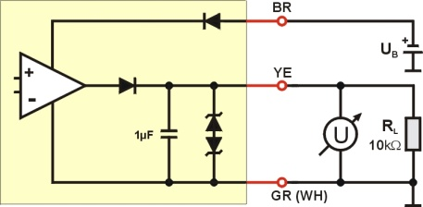 | 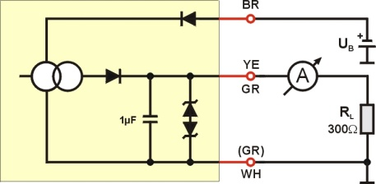
U_{A} = 0 ... 10 V R_{L} ≥ 10 kΩ | I_{A} = 4 ... 20 mA R_{L} ≤ 300 Ω
Figure 4
The apparent ohmic resistance R_{L} must be connected between the signal output and GND (see Figure 4). Load capacity C_{L} is limited to a maximum of 10 nF.

Signalization

Light emitting diodes
The sensor is equipped with 2 light emitting diodes (LED) indicating its functional state.
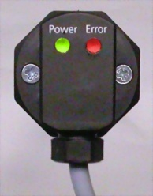
LED 2
Flow
LED 1
Figure 5
Operating state | LED 1 | LED 2
Supply voltage too low
Ready for operation
Supply voltage too high
Medium temperature beyond specification range
Sensor defective
Table 6
 | LED off |  | LED flashes (approx. 2 Hz): green
 | LED on: green |  | LED flashes (approx. 2 Hz): red

Analog outputs
- Error signaling
If the supply voltage is too high or if the sensor detects a defect, one respectively both interfaces emit 0 V or 2 mA.
- Representation of the measuring range
The measuring range of the corresponding measuring value is mapped in a linear way to the signaling range of its analog output.
For flow measurement the measuring range reaches from zero to the selectable end of the measuring range w_{N,max} (= 100 % in Figure 6). A higher flow up to 110 % (= 11 V or 21.6 mA) is still output in a linear way, moreover the signal remains constant.
Voltage output w_{N} | Current interface w_{N}
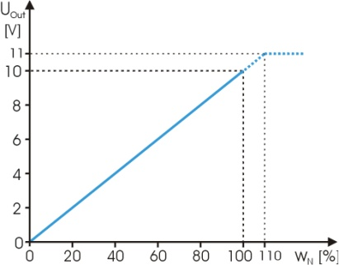 | 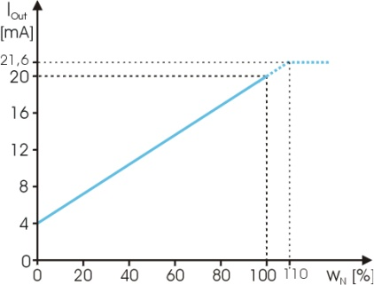
Figure 6 Representation for flow velocity
The measuring range of the medium temperature is -20 to +120 °C (Figure 7). Falling below this temperature it is still output in a linear way down to -30 °C (3 mA), going deeper the signal remains constant. An exceeded of the temperature range is output in a linear way up to +130 °C (21.2 mA), moreover this output remains constant.
For a correct temperature measurement, the flow velocity on the sensor head must be > 2 m/s. An excessive temperature value is output if flow velocity is < 2 m/s.

Current interface T_{M}
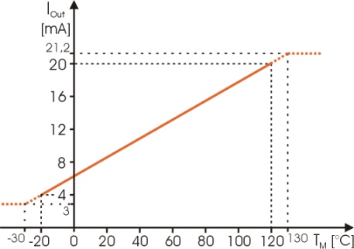
Figure 7 Representation for medium temperature
Even short-term overshooting of the operating medium temperature can cause irreversible damage of the sensor.

Startup
Prior to switching on the SCHMIDT® flow sensor SS 20.260, the following checks have to be carried out:
- Immersion depth of the sensor probe and alignment of the housing
- Tightening of the fastening screw of the compression fitting
- Correct electrical connection in the field (switch cabinet or similar)
Prior to startup the sensor check mounting and electrical connection.
5 seconds after switch-on the sensor is ready for operation. If the sensor has another temperature than the ambient, this time is prolonged until the sensor has reached its ambient temperature.
If the sensor has been stored at very cold conditions, before commissioning you have to wait until the sensor and its housing have reached ambient temperature.

Information concerning operation
Soiling or other gratings on the sensor cause distortions of measurements.
Therefore, the sensor must be checked for soiling at regular intervals and cleaned if necessary.
(Condensating) liquid on the sensor causes serious measurement distortions.
After drying the correct measuring function is restored.

Eliminating malfunctions
The following Table 7 lists possible errors (error images). A description of the way to detect errors is given. Furthermore, the possible causes and measures to be taken to eliminate errors are listed.
Error image |  | Possible causes | Troubleshooting
 |  | Problems with supply voltage U_{B}:  - No U_{B} available  - U_{B} has wrong polarity  - U_{B} < 15 V  Sensor defective | - Sensor cable connected correctly?  - Supply voltage connected to the control?  - Supply cable broken?  - Power supply unit large enough?
I_{wN} , I_{TM} = 0 mA
 |  | Sensor element defective | Send in sensor for repair
I_{wN} , I_{TM} = 2 mA |  | Sensor element defective | Send in sensor for repair
 |  | Operating voltage too high | Check the operating voltage and reduce it
I_{wN} , I_{TM} = 2 mA |  | Operating voltage too high | Check the operating voltage and reduce it
Flow signal w_{N} is too large / small |  | Measuring range too small /large  Medium is not air  Sensor element soiled  Sensor installed in opposite direction to flow direction | Check sensor configuration  Check measuring resistance  Is the foreign gas factor correct?  Clean sensor tip  Check the installation direction
Flow signal w_{N} is fluctuating |  | U_{B} unstable  Mounting conditions:  - Sensor head is not in optimal position  - Run-in/run-out distance is too short  Strong fluctuations of pressure or temperature | Check the voltage supply  Check mounting conditions  Check operating parameters
Table 7

Service information

Maintenance
Soiling of the sensor element may lead to a wrong measuring result. The sensor tip must be checked regularly for soiling and must be cleaned when required.

Cleaning of the sensor tip
The sensor tip can be cleaned to remove dust or soiling by moving it carefully in warm water containing a washing-up liquid. If necessary a soft brush can be used additionally.
Do not use strong cleaners, solvents, brush or other hard objects.
Before putting it again into operation, wait until the sensor tip is completely dry.

Transport / shipment of the sensor
Before transport or shipment of the sensor, the delivered protective cap must be placed onto the sensor tip. Avoid soiling or mechanical stress.

Recalibration
If the customer has made no other provisions, we recommend repeating the calibration at a 12-month interval. To do so, the sensor must be sent in to the manufacturer.

Spare parts or repair
No spare parts are available, since a repair is only possible at the manufacturer's facilities. In case of defects the sensors must be sent in to the producer for repair.
If the sensor is used in systems important for operation, we recommend you to keep a replacement sensor in stock.

Test certificates and material certificates
Every new sensor is accompanied by a certificate of compliance according to EN10204-2.1. Material certificates are not available.
Upon request, we shall prepare, at a charge, a factory calibration certificate, traceable to national standards.

Technical data
Measuring parameters | Standard velocity w_{N} of air, based on standard conditions 20 °C and 1013.25 hPa  Medium temperature T_{M}
Medium to be measured | Air or nitrogen, other gases on request
Measuring range w_{N} | 0 ... 2.5 / 10 / 20 / 40 / 50 m/s
Lower detection limit w_{N} | 0.2 m/s
Measuring accuracy w_{N}  - Standard  - Precision* | ±(5 % of measured value + [0.4 % of final value; min. 0.02 m/s])  ±(3 % of measured value + [0.4 % of final value; min. 0.02 m/s])
Reproducibility w_{N} | ±1,5 % of measured value
Response time (t₉₀ ) w_{N} | 3s (jump from 5 to 0 m/s)
Temperature gradient w_{N} | < 8 K/min (@ 5 m/s)
Measuring range T_{M} | -20 ... +120 °C
Measuring accuracy T_{M}  (w_{N} ≥ 2 m/s) | ±1 K (0 ... 40 °C)  ±2 K (remaining measuring range)
Operating temperature  - Medium  - Electronics | -20 ... +120 °C  0 ... +70 °C
Humidity range | 0 ... 95 % rel. humidity (RH), non-condensing
Operating pressure | atmospheric (700 ... 1300 mbar)
Operating voltage U_{B} | 24 V_{DC} ± 10 % (reverse voltage protected)
Mounting tolerance | ±3° (relative to flow direction)
Current consumption | < 60 mA
Analog outputs  - Type voltage (U)  - Typ current (I)  - Load capacity | 1 or 2 (short-circuit protected)  0 ... 10 V (R_{L} ≥ 10 kΩ)  4 ... 20 mA** (R_{L} ≤ 300 Ω)  C_{L} ≤ 10 nF
Electrical connection | Cable fixed on housing, 4-pin, length 2 m, pigtail***
Line length | ≤ 15 m (U) / 100 m (I)
Protection class | III (PELV) **** according EN 50178)
Type of protection | IP 65
Mounting | Thread M18 x 1 at sensor enclosure, accessories (option)
Installation length | 50 / 100/ 200 / 350 / 500 mm
Weight | 200 g max.
Table 8

EC Declaration of conformity
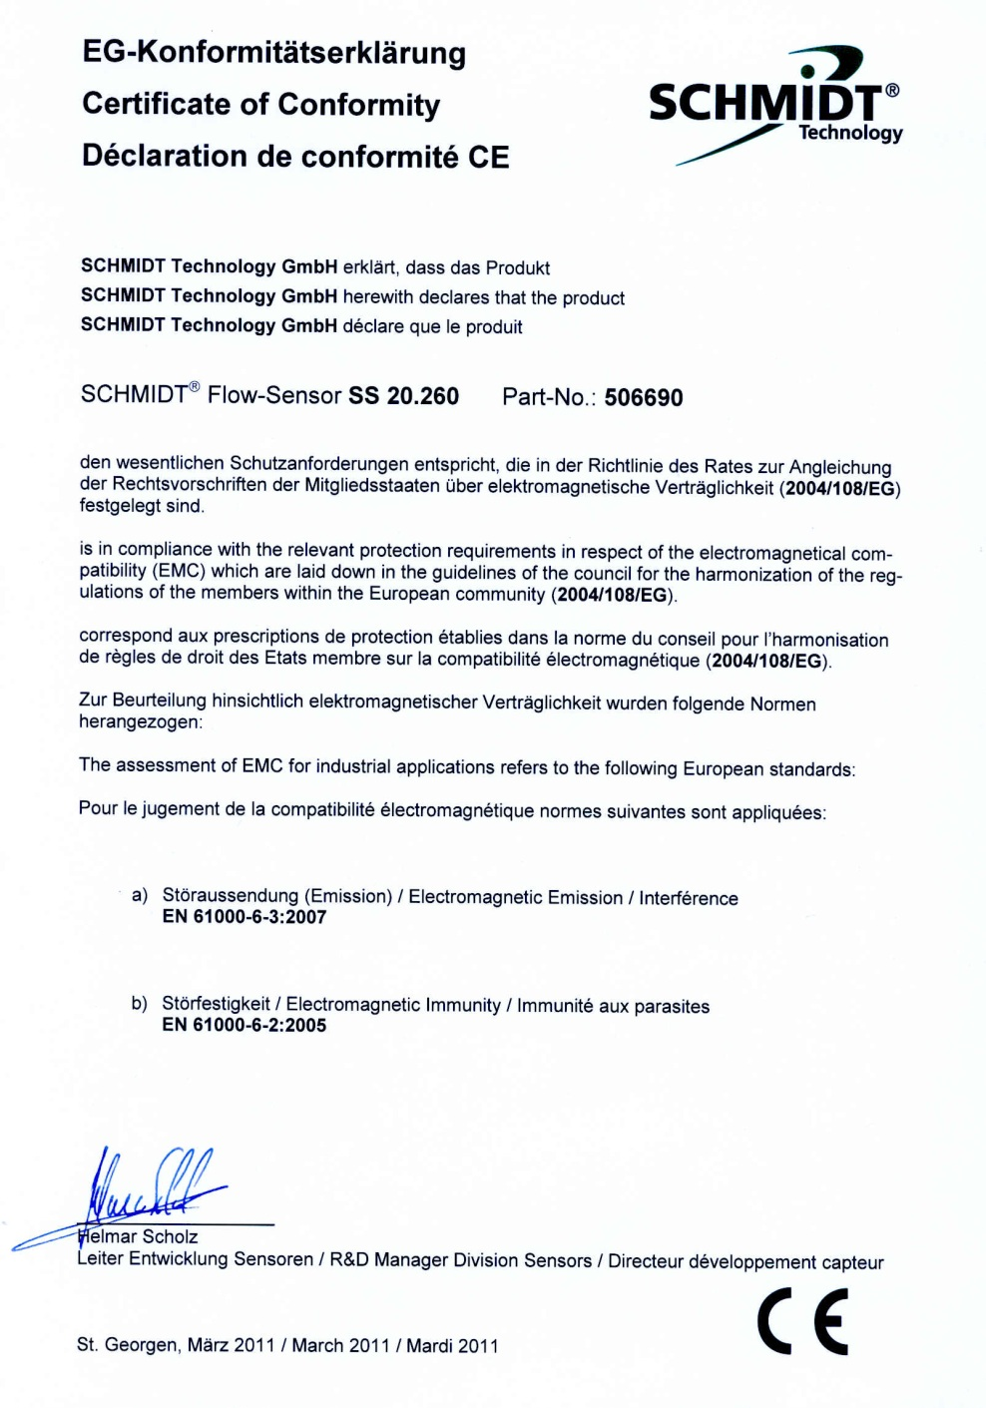
Notes:

SCHMIDT Technology GmbH
Feldbergstrasse 1
78112 St. Georgen / Germany
Phone +49 (0)7724 / 899-0
Fax +49 (0)7724 / 899-101
sensors@schmidttechnology.de
www.schmidttechnology.de

Equates to the real flow velocity under standard conditions
Measurement deviation < 1 %
Alternatively flow rectifier could be used, e.g. honeycomb ceramics
Considers parabolic flow profile and sensor obstruction
Must be welded
It is recommended, to use AGND as measuring reference potential for tension output.
In accordance with NAMUR specification
* Under alignment conditions and with regard to the reproducibility of the reference
** Error messaging: 2 mA; exceeding measuring range: up to 22 mA
*** With cable end sleeves
**** According EN 50178

