Certified according to DIN ISO 9001

Manual
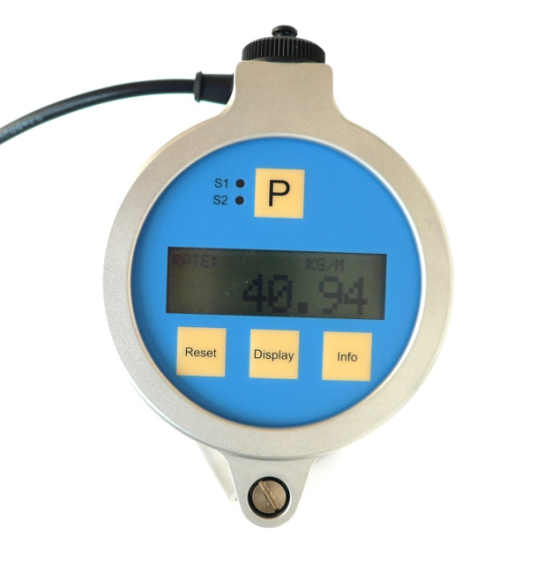


VTC / VIC Local Display
with integrated Temperature Measurement,
Analog and Digital Output

SW-Version
Main: V02.12
Manual-Revision: 002

1 General Information 5
1.1 Features 5
1.2 Safety 5
1.2.1 General Safety 5
1.2.2 Safety Requirements for Ex installations 5
1.2.3 Warnings in this manual 6
1.3 Ordering Codes and Accessories 6
1.3.1 Ordering Code 6
1.3.2 Accessories 6
2 Getting started 7
2.1 Unpacking 7
2.2 Operating Elements 7
2.2.1 Operating elements Front Side 7
2.2.2 Operating Elements Back Side 8
2.3 Pin Assignments 9
2.3.1 Pin assignment connector 8 pin 9
2.3.2 Pin assignment screw type terminal 9
2.4 Quick start 10
2.4.1 First Operation 10
2.4.2 Manual Control 11
3 Installation 12
3.1 Mechanical Installation 12
3.2 Electrical Installation 12
3.2.1 Electrical Installation VTC / VIC with screw type terminals 13
3.2.2 Power Supply and Grounding 13
3.2.3 Operation as passive 4-20 mA sensor 14
3.2.4 Operation with current and frequency output 14
3.2.5 Operation with frequency output only 16
3.2.6 Operation as indicator without outputs 17
4 Manual Operation 18
4.1 Power On Sequence and Principles of Manual Control 18
4.2 Measuring mode 19
4.2.1 Function of the keys 19
4.2.2 Display selection 19
4.2.3 Resetting the batch value 19
4.2.4 Info Menu 19
4.3 Control Mode 20
4.3.1 Function of the keys 20
4.3.2 Submenus in the Main Menu 20
4.3.3 DISPLAY Menu 21
4.3.3.1 FLOW DISPLAY menu 21
4.3.3.2 TOTAL DISPL menu 23
4.3.3.3 DENS DISPLAY menu 23
4.3.3.4 TEMP DISPLAY menu 24
4.3.4 SETUP Menu 24
4.3.4.1 K-FACTOR menu 25
4.3.4.2 CUT-OFF menu 26
4.3.4.3 FLOW-FILTER menu 26
4.3.4.4 DENSITY menu 26
4.3.4.5 DIG.OUT menu 27
4.3.4.6 ANALOG-OUT menu 31
4.3.4.7 CTL-INPUT menu 32
4.3.4.8 LINEAR menu 32
4.3.4.9 KEY-RESET menu 32
4.3.4.10 SAVE DATA menu 33
4.3.4.11 RECALL DATA menu 33
4.3.5 LINEAR Menu 34
4.3.6 I/O TEST Menu 35
4.3.7 SERVICE Menu 36
5 Remote operation 37
5.1 Standard interface 37
5.1.1 Electrical connections 37
5.2 USB interface 38
5.2.1 Electrical connection 38
5.3 HART 38
5.3.1 Electrical connection for HART 38
5.3.2 HART Interface Protocol 38
6 Service and Maintenance 39
6.1 Maintenance 39
6.2 Service 39
6.3 Calibration 39
6.3.1 Calibrating the current output 40
6.3.2 Calibrating the temperature measurement 41
6.3.3 Reset the TOTAL counter 41
6.4 Trouble shooting 41
7 Listings 42
7.1 Warranty 42
7.2 Certifications and compliances 42
7.3 Technical Data 44
7.3.1 Dimensional Drawings 46
7.4 WEEE and RoHS 48
7.5 List of figures 48
7.6 Addresses 48

General Information

Features
The VTC / VIC are compact, intelligent local displays with built in carrier frequency (VTC) or inductive (VIC) pickup.
They can be used as passive 4-20mA sensors (2 wire operation) or with auxiliary supply also as sensors with frequency or switch output.
They can be adjusted to any flow meter, as the K- factor is freely settable. The selectable dimensions include virtually all worldwide used dimensions.
The 20 point linearization of the input signal provides the possibility to display also strongly nonlinear signals with high accuracy.
Via a temperature sensor in the pickup tip the medium temperature can be measured.
As a standard the VTC / VIC (except the versions with NAMUR output) are equipped with a proprietary interface which can be converted to USB via the external converter CON.USB.WT. As an option USB and HART interfaces are available.
For fast test setups in the lab and easy setup of individual parameters, the PC based control SW EasyControl for WINDOWS ® XP,VISTA and 7 is available free of charge.

Safety

General Safety
All statements regarding safety of operation and technical data in this manual will only apply when the unit is operated correctly in accordance with this manual.
The data for Ingress Protection will only apply when all connectors are caped properly with the corresponding counterpart with the same or better IP rating. Cable glands must be populated with cables with the specified diameter and closed properly.
During operation all openings of the housing must be closed unless otherwise noted in this manual.
All connections to the load and to the supply must be made with shielded cables unless otherwise noted in this manual. This unit must be grounded.
This unit must be supplied by a safety approved power supply with outputs which comply with Safety Extra Low Voltage (SELV).
As a protection against fire in the positive supply a fuse with a current rating not higher than the current carrying capacity of the cable used is required.
National and international standards regarding electrical installation have to be adhered to.
The devices described in this manual may only be connected and operated by authorized and qualified personnel.

Safety Requirements for Ex installations
When the VTC / VIC are to be used in hazardous areas, suitable isolation amplifiers or barriers have to be used.
When using long cables make sure that the maximum inductances and capacitances for the respective voltage or gas group are not exceeded.
The USB interface must not be used in hazardous areas.
Only Ex certified units may be used in hazardous areas.

Warnings in this manual
Note:
Notes provide important information for the correct usage of the equipment. If the notes are not observed, a malfunction of the equipment is possible.
WARNING!
Warnings provide very important information for the correct usage of the equipment. Not observing the warnings may lead to danger for the equipment and to danger for health and life of the user

Ordering Codes and Accessories

Ordering Code
VTC |  |  | - K |  | - 8 |  | - H |  | - P |  | - Exi
 |  |  |  |  |  |  |  |  |  |  |  |  |  | Exi = Ex-Version Ex i
 |  |  |  |  |  |  |  |  |  |  |  |  |  | Exn = Ex 3G for Zone 2
 |  |  |  |  |  |  |  |  |  |  |  |  |  | N = NAMUR output, galvanically free
 |  |  |  |  |  |  |  |  |  |  |  |  |  | P = Push-Pulloutput
 |  |  |  |  |  |  |  |  |  |  |  |  |  | H = HART Interface
 |  |  |  |  |  |  |  |  |  |  |  |  |  | N = KEM Interface
 |  |  |  |  |  |  |  |  |  |  |  |  |  | U = USB Interface
 |  |  |  |  |  |  |  |  |  |  |  |  |  | K = Screw type terminals
 |  |  |  |  |  |  |  |  |  |  |  |  |  | 8 = ConnectorM12, 8-pin
 |  |  |  |  |  |  |  |  |  |  |  |  |  | K = Pickup short
 |  |  |  |  |  |  |  |  |  |  |  |  |  | L = Pickup long
 |  |  |  |  |  |  |  |  |  |  |  |  |  | R = Pickup short with step
 |  |  |  |  |  |  |  |  |  |  |  |  |  | S = Pickup long with step
 |  |  |  |  |  |  |  |  |  |  |  |  |  | C = Pickup long for HMC
 |  |  |  |  |  |  |  |  |  |  |  |  |  | VIC = Induktive pickup
 |  |  |  |  |  |  |  |  |  |  |  |  |  | VTC = Carrier frequencyz-pickup

Accessories
Ordering Code Description
CON.USB.WT Interface converter to USB
Upon request Connector M12; type 713
Upon request cable, 8-pin, black, 5 m with connector M12

Getting started

Unpacking
Verify that you have received the following items:
VTC / VIC
This manual

Operating Elements

Operating elements Front Side

21

1
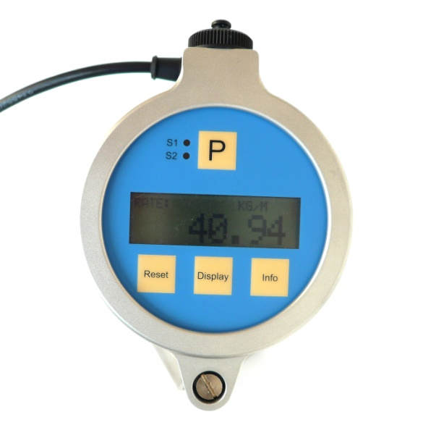
8
6
7
5
3
4

Fig. 1: Operating elements ront side
1 = LED „S1“, lights green, iv the control output is in the active state
2 = LED „S2”, lights red, if the loop current exceeds 20mA
3 = Display
4 = Pushbutton „P“, opens a selected menu and/or confirms the settings
5 = Pushbutton „RESET“, Measuring: resets the batch counter, Setup: Softkey
6 = Pushbutton „DISPLAY“, Measuring: changes the display, Setup: Softkey
7 = Pushbutton „INFO“, Measuring: opens the Info menu, Setup: Softkey
8 = Screw for opening the top cover

Operating Elements Back Side

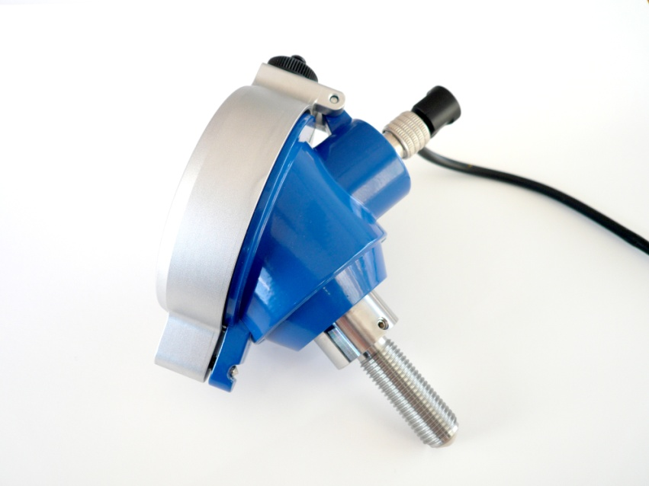
4
1
3

5
Fig. 2: Operating elemente side view
1 = USB interface (option)
2 = I/O connector
or cable gland
3 = Screw for fixing the display orientation
4 = Sensor fixing nut
5 = Sensor tip with M14 thread

Pin Assignments

Pin assignment connector 8 pin
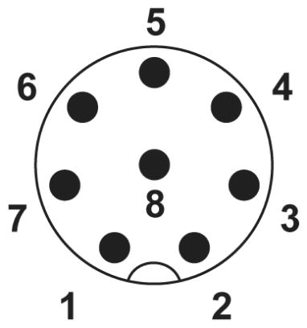
1 +I (positive supply 2- and 3- wire operation)
2 -I (current output, negative supply with 2 wire operation)
3 Ground terminal with 3 wire operation
4 Frequency output
5 Control and communication input 1
6 +24V supply for 4 (PP) / Control input 2 (NAMUR)
7 Control input 2 (PP) / n.c. (NAMUR)
8 PE

For an exact description of all inputs and outputs see chapter 3.2.

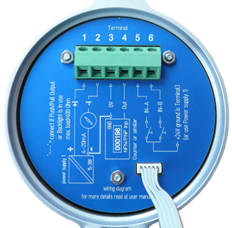
Pin assignment screw type terminal
1 +I (positive supply 2- and 3- wire operation)
2 -I (current output, negative supply with 2 wire operation)
3 Ground terminal with 3 wire operation
4 Frequency output
5 Control and communication input 1
6 +24V supply for 4 (PP) / Control input 2 (NAMUR)

For an exact description of all inputs and outputs see chapter 3.2.

Quick start
WARNING:
As for safety and accuracy reasons many precautions must be taken, read chapter 3 carefully before installing the unit!
In case the unit has only to be operated for testing or learning purpose, the following connections have to be made (see chapter 3.2):
- Screw – if required – the VTC / VIC into the meter
- Connect the 24V DC supply
- The frequency and analog outputs as well as the interface may be connected as well, if those features are required
With built in USB interface the VTC / VIC can be operated from USB as well, if no output signal is required.
WARNING:
If the unit is connected to a bigger system, for your personal safety connect the protective ground as well!

First Operation
Make sure that all mechanical and electrical connections are made properly.
Switch on the power supply.
After the power up sequence the display shows the preselected values.
If there is a flow (or as rotating tooth wheel), the corresponding flow will be calculated according to the set k- factor and will be displayed.
The display view can be altered by pressing the key “Display”.
The device status information can be viewed by pressing the key “Info” for 3 seconds.
If the function is activated, the BATCH reading can be reset to zero by pressing the key “Reset”.
For entering the SETUP menu press “P” for 3 seconds.

Manual Control
In the manual control menus all configurations can be made. The submenus, in which the functionality of the VTC / VIC or any factors can be altered, are protected by passwords.
The menu itself is self-explaining, the function of the softkeys (5, 6, 7) is indicated in the display above the pushbutton.
For entering the manual control menu press the pushbutton “P” (4) until the display shows:
MAIN MENU
DISPLAY
DOWN UP EXIT

Select the desired submenu with “UP” or “DOWN” and confirm with “P” (4).
If the submenu is protected by password, the display shows:
ENTER CODE
882297
LEFT UP EXIT

Change the indicated number with the softkeys “LEFT” and “UP” (6) to “882207” and confirm with “P” (4).
Select the desired submenu or function with “NEXT” or “UP” and “DOWN” and confirm with “P” (4).
Every setting must be confirmed with “P” (4) for storing the setting or with “EXIT” for exiting without storing.
For leaving any menu press “EXIT” (7) several times until the measuring menu reappears.

Installation
Note
All installations must only be executed by qualified personnel.

Mechanical Installation
Screw the sensor tip of the VTC / VIC by hand (without tools) into the M14x1.5 sensor thread of the meter until you reach the stop.
Warning
Too much force will damage the sensor tip!
Turn backwards the VTC / VIC by 45°.
Fix the VTC / VIC with the fixing nut.
note:
If you turn backwards the VTC / VIC by more than 90°, the flow might not be measured correctly. If you do not turn back the VTC / VIC, the sensor tip might be damaged with strong temperature changes.
For adjusting the display orientation, open the 2 headless screws with a 2mm Allan key by about 1 turn.
Rotate the display to the desired position and reaffix the headless screws.

Electrical Installation
Make sure that the unit is properly mounted before making the electrical connections.
note:
Switch off the power supply before making changes at the electrical installation.
This unit must be grounded.
The VTC / VIC requires a regulated DC power supply of 24V nominal and works properly over a supply range of 15V to 30V.
For connecting the VTC / VIC, shielded cables must be used. The shield should be connected to the PE terminal. If in bigger systems the shield must not present a DC connection for avoiding high ground loop currents, make the ground connection of the shield via a capacitor of e. g. 100nF.
WARNING
Improper grounding and shielding may lead to bad EMC behavior or danger to your health!
NOTE
Make sure that all cable and wires are connected and fixed properly before applying power to the VTC / VIC.

Electrical Installation VTC / VIC with screw type terminals
Prepare the cable for installation:
- Separate the single conductors for about 8cm
- Strip the end for about 7mm and cover it with a cable end sleeve
- Connect if necessary a stranded wire to the shield
Open the holding screw in the top cover and open the top cover carefully.
Feed the cable through the cable gland.
Connect the wire according to chapter 3.2.2 to3.2.6.
Adjust the position of the cable in the cable gland in that way that the single conductors remain short but free of tension and fix the cable in the cable gland.
Close the top cover and reaffix the retention screw.

Power Supply and Grounding
The power supply input of the VTC / VIC has an internal diode against reverse polarity.
All pins of the connector are RF blocked to the case (PE) by 2.2nF capacitors. For proper operation therefor the case must be grounded. The grounding might be done via the cable shield or via the meter.
Note:
In bigger systems the cable shield must not be the only PE connection.
For best RF behavior the power supply should be grounded at 1 point in the system

Operation as passive 4-20 mA sensor
For operating the VTC / VIC as passive 4-20mA senor, only pin 1 and 2 are to be connected.
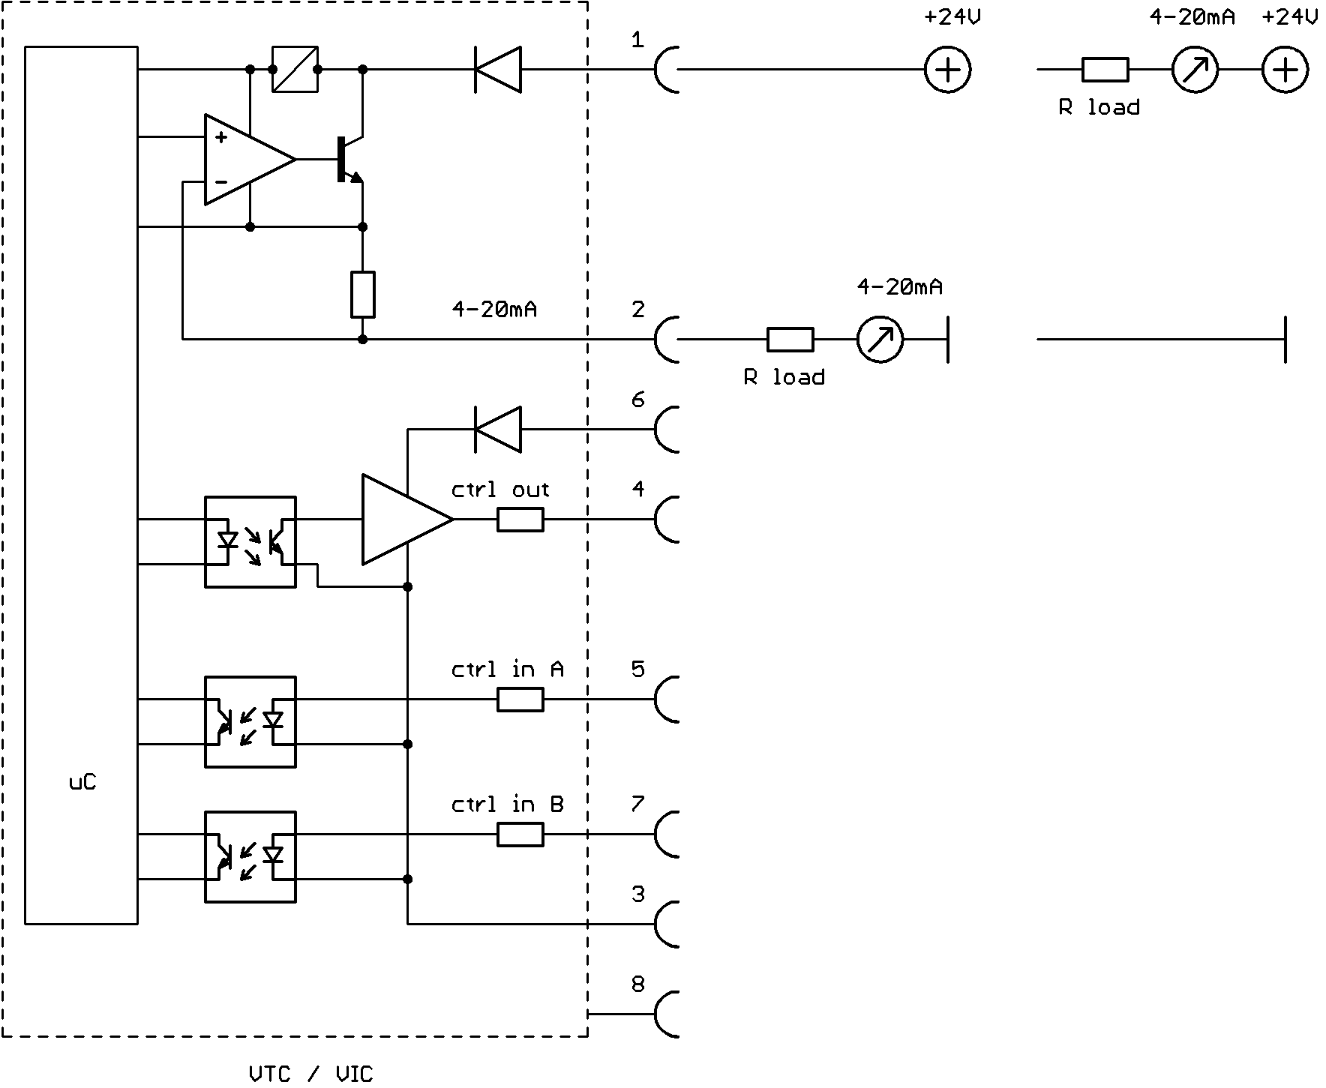
Fig. 3: Wiring diagram passive 4-20mA sensor
The maximum load resistance (input resistance of the ammeter plus protective resistor) can be calculated as
R_{Lmax} = (U_{B} – 15V) / 20.5mA
The load resistor plus the ammeter can be connected in the positive or in the negative supply rail.
With 2 wire passive operation there is no display backlight.
Versions with NAMUR frequency output are to be connected in the same way.

Operation with current and frequency output
If with versions with push-pull output pin 3 is connected to the positive supply and pin 3 to GND, the push pull frequency output is powered up as well and the backlight lights up.
Versions with NAMUR output do not have a separate power supply terminal and do not provide a backlight.
For the supply of the analog output (pin 1 and 2) and the digital output (pin 3 and 6), according to the requirement, separate supplies or a common supply might be used.
For the maximum load resistance refer to chapter 3.2.3
note:
If pin 1 and 2 are left open, the µC of the VTC / VIC will not operate at all!
Versions with screw type terminal do not have terminals 7 and 8.
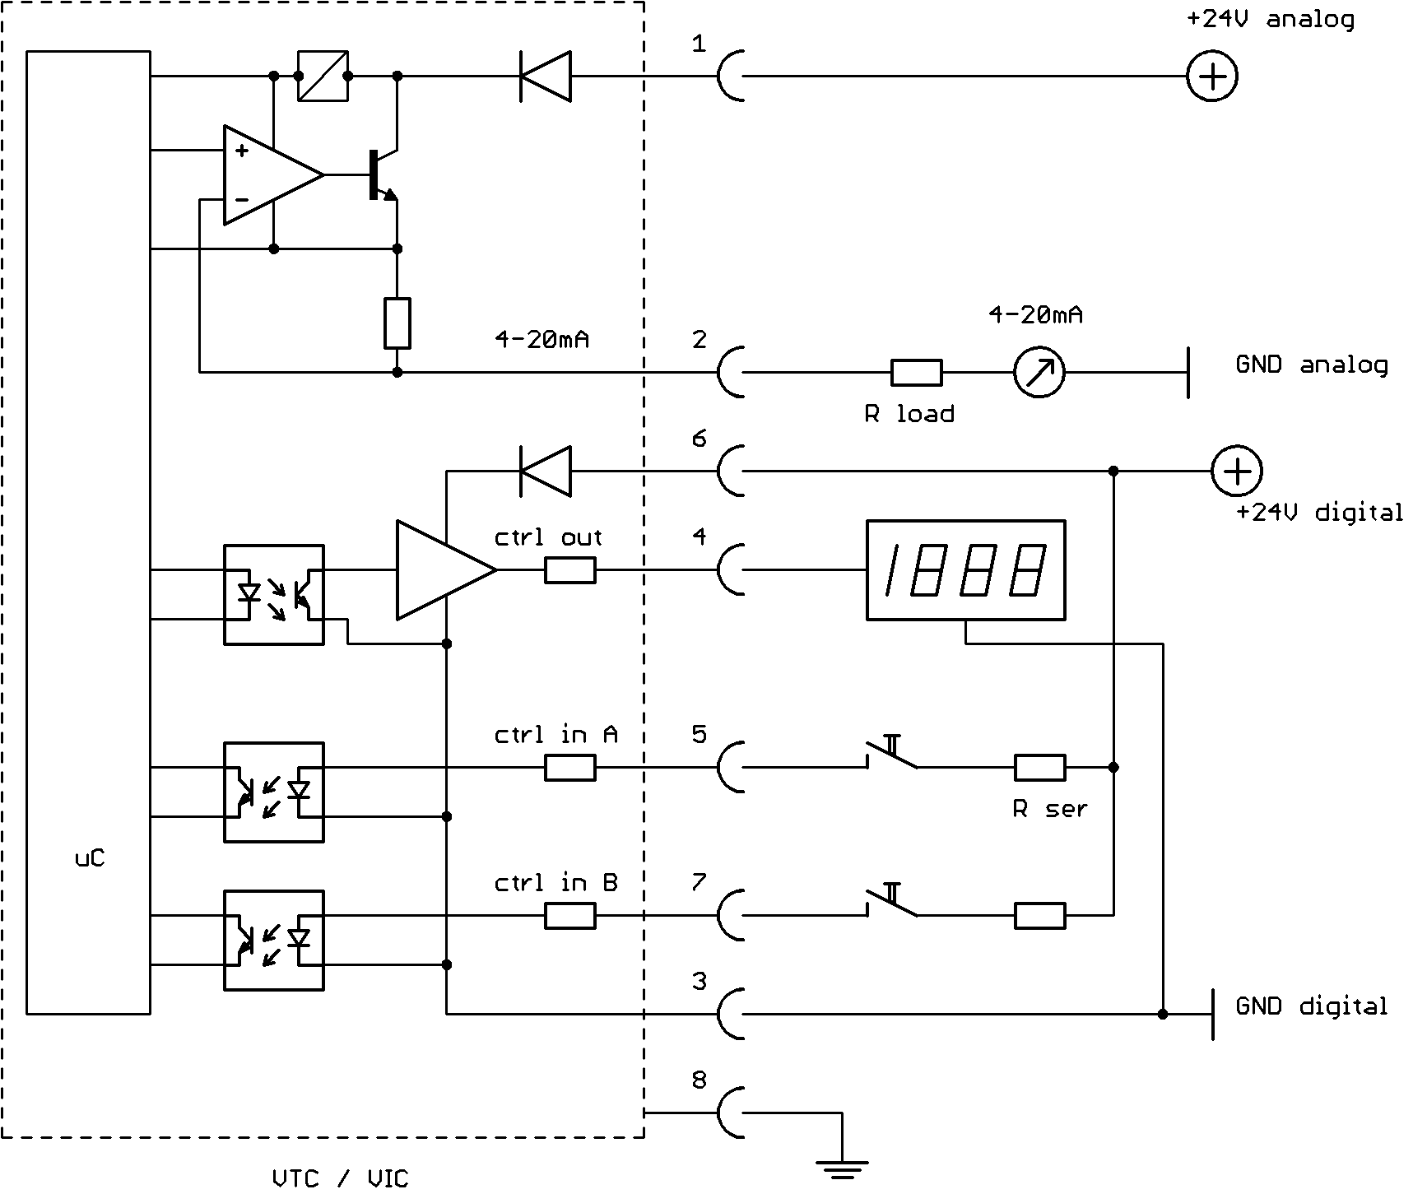
Fig. 4: Wiring diagram 3 wire operation with analog and frequency output, push-pull output
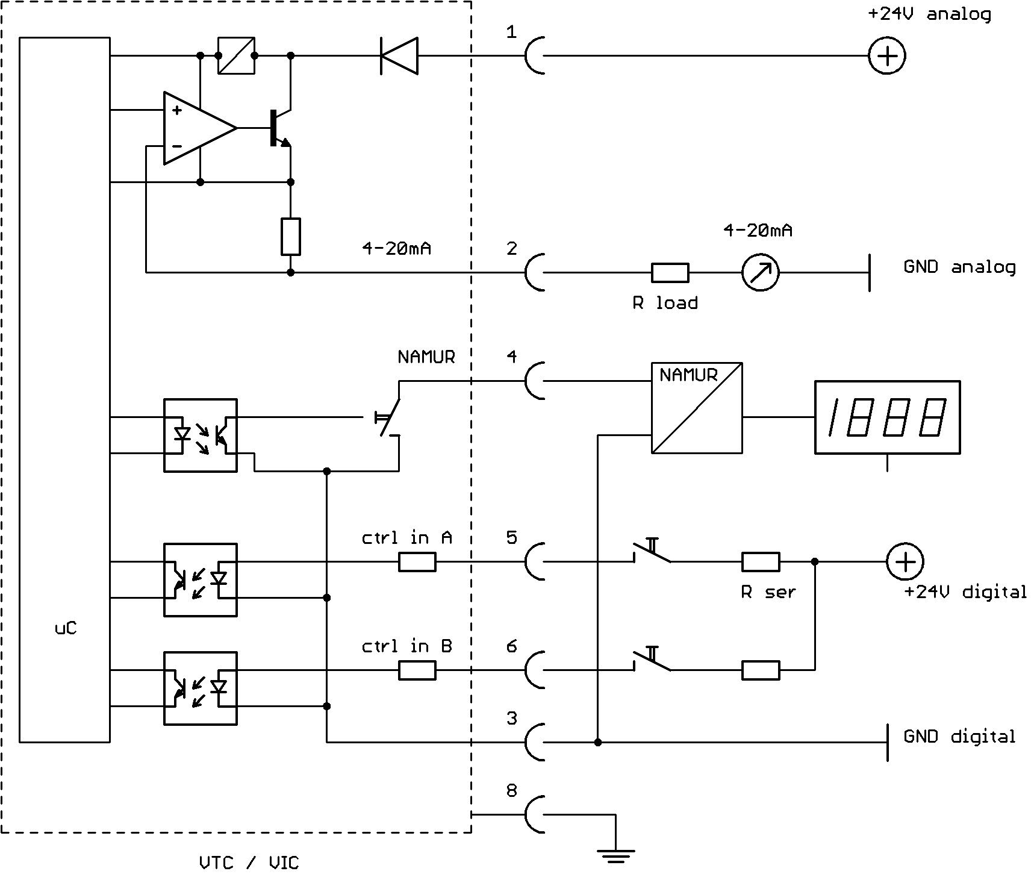
Fig. 5: Wiring diagram 3 wire operation with analog and frequency output, NAMUR output
The digital output is an asymmetrical push pull output stage with R1 = 720 Ω and R2 = Ω.
The high and low output voltages can be calculated as:
V_{high} = V_{supply} – 0.5V - 720Ω * I_{load}
V_{low} = 470Ω * I_{load}
The output is short circuit prove.
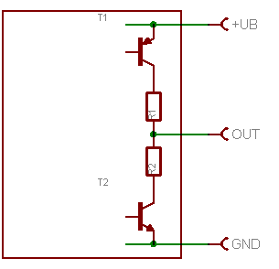
Fig. 6: Digital output stage of the VTC / VIC

Operation with frequency output only
Connect the VTC / VIC according to the diagram.

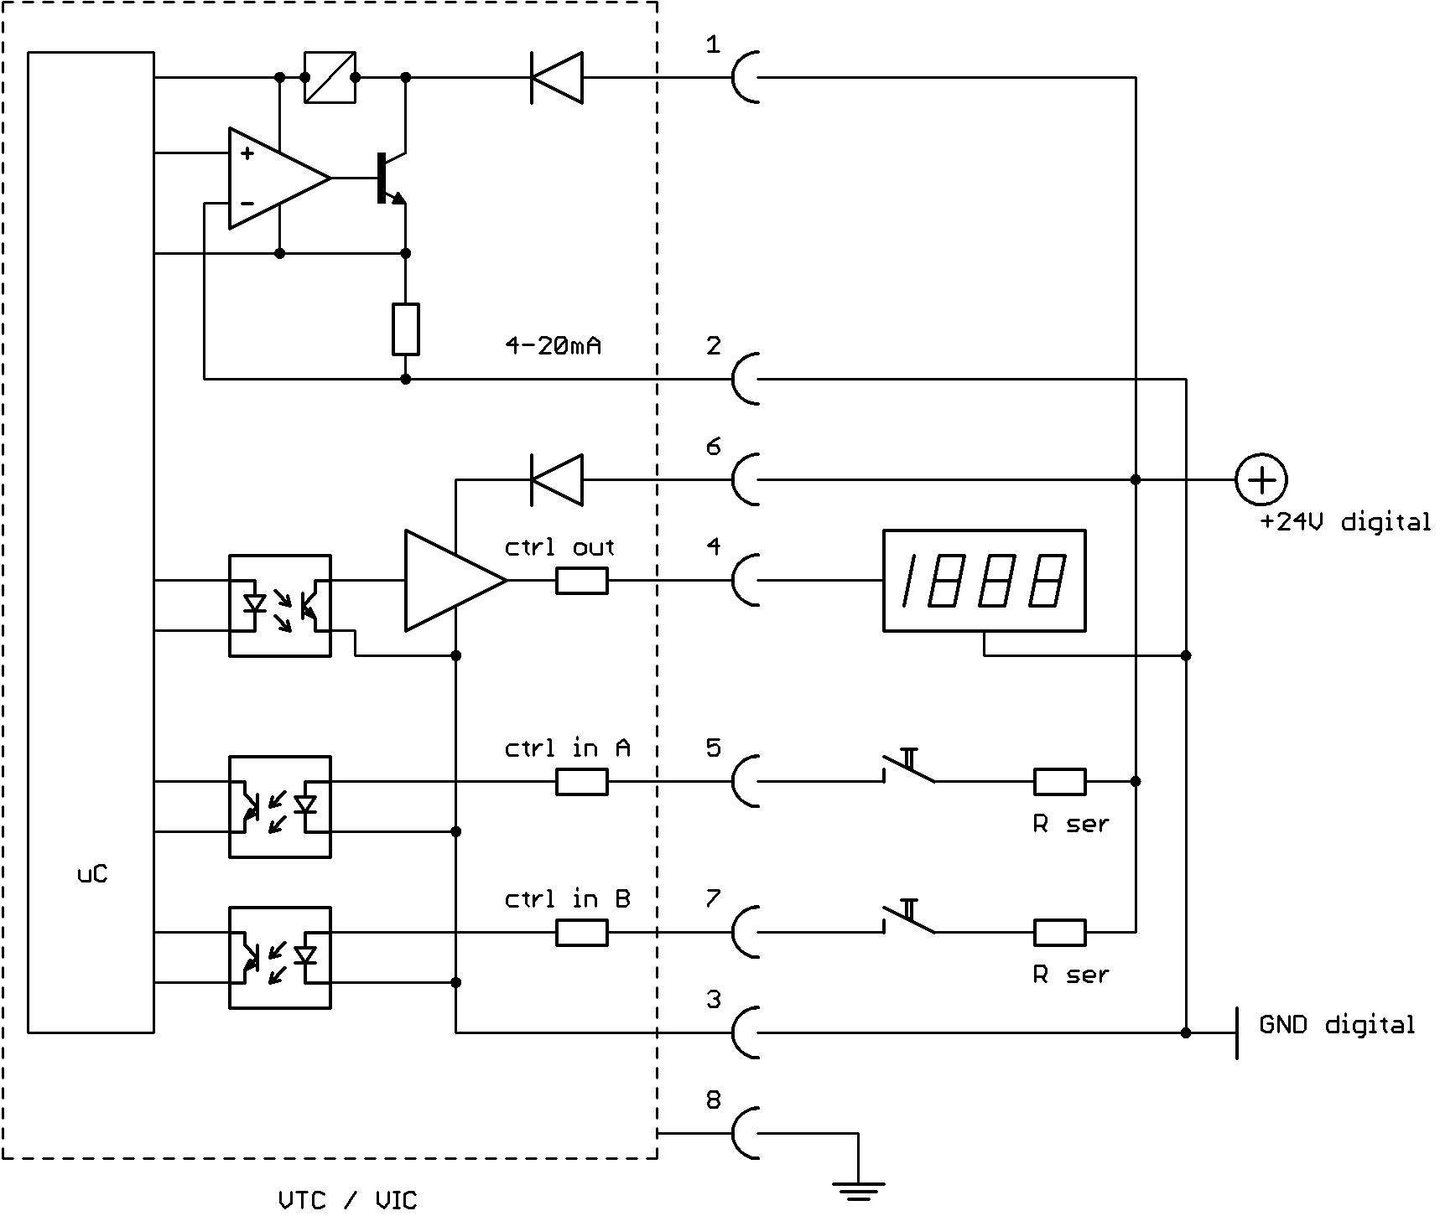

Fig. 7: Wiring diagram 3 wire active with frequency output only, push-pull output
For the description of the frequency output refer to chapter 3.2.4.
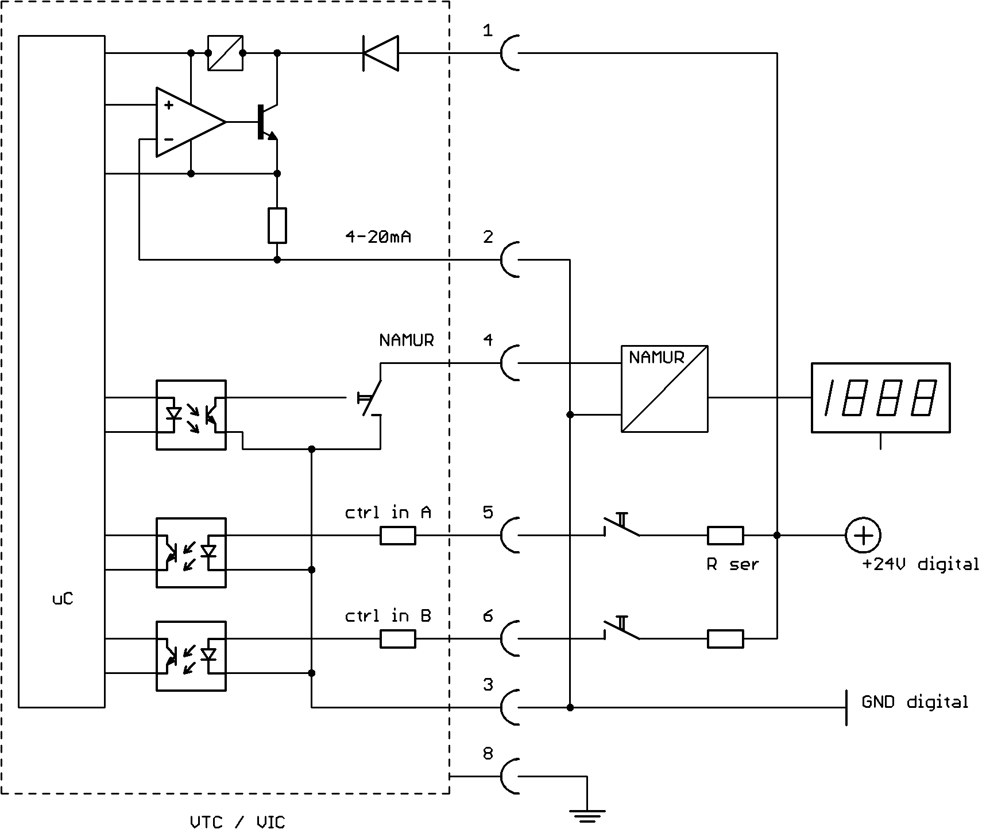
Fig. 8: Wiring diagram 3 wire active with frequency output only, NAMUR output
In this operating mode the current output can be set to “4mA constant”, which reduces the power dissipation in the VTC / VIC.
note:
If pin 1 and 2 are left open, the µC of the VTC / VIC will not operate at all!
Versions with screw type terminal do not have terminals 7 and 8.

Operation as indicator without outputs
If the VTC / VIC is to be used just as an indicator only, connect terminal 1 to the positive supply and terminal 2 to the supply GND.
In this operating mode the current output can be set to “4mA constant”, which reduces the power dissipation in the VTC / VIC.
If additionally pin 3 is connected to GND and pin 6 to the positive supply, the backlight lights up (versions with push-pull output only).

Manual Operation

Power On Sequence and Principles of Manual Control
For about 2 second the display shows the device name and the SW version:
VTC
SW-NR:02.02

Now the VTC / VIC switches to the measuring mode, displaying the last active screen, e.g.:
0.000^{RATE}
0.00^{BATCH}

In manual control the VTC / VIC is menu driven and provides 2 operational modes, the “Measuring Mode” and the “Control Mode”.
In the measuring mode the display shows the preselected measured values and all 4 pushbuttons have the function printed on them. The switch over between the different measuring displays can be made at any time without interrupting the measurements.
If a value to be displayed exceeds the display range, the display shows “OVERFLOW”.
In the control mode the 3 pushbuttons below the display have varying functions. The actual function is indicated in the display, just above the pushbutton.
In the control menu all necessary settings can be made.
The control menu contains the submenus “DISPLAY”, “SETUP”, “LINEAR” (only units with built in linearization), “I/O-TEST” and “SERVICE”.
In the menu “DISPLAY” the local display of the unit can be adapted to the actual needs. All settings made in this menu have no influence on the measurements.
In the menu “SETUP” all settings to adapt the unit to the actual needs can be made, like configuring the inputs and outputs.
In the menu “I/O-TEST” all inputs and outputs can be tested after the installation.
In the menu “LINEAR” (linearization) the parameters for the built in linearization can be set.
The menu “SERVICE” allows for calibration of the unit.
For protecting the unit against unintentional changes by unauthorized personnel, the menus “SETUP”, “LINEAR” and “I/O-TEST” are protected by a user password and the menu “SERVICE” by a service password.

Measuring mode

Function of the keys
In the measuring mode all pushbuttons have a fixed function:
P | Opens the Control Menu if pressed for > 3 seconds
Reset | Resets the batch counter to zero, if the function “KEY RESET” is enabled
Display | Toggles the display between the different screens.
Info | Opens the info menu

Display selection
The VTC / VIC provides the following display:
RATE:
The display shows the actual flow with the selected resolution and engineering unit.
BATCH:
The display shows the BATCH counter with the selected resolution and engineering unit.
TOTAL:
The display shows the TOTAL counter with the selected resolution and engineering unit.
TEMP:
The display shows the actual temperature with the selected engineering unit.
RATE-BATCH:
The display shows the actual flow and the BATCH counter with the selected resolution and engineering unit.
GRAPH 1:
The display shows the flow over the last 30s. 100% equals the value specified for 20mA loop current.
GRAPH 2:
The display shows the actual flow in percent as bar graph and as a number.
For changing from on display to the other just press the pushbutton “Display”.
For changing the settings of the displays refer to chapter 4.3.3.

Resetting the batch value
For easy batching in local operation the VTC / VIC provides the possibility to reset the batch value by pressing the pushbutton “Reset”.
Resetting is only possible, if the display screen “Batch” is active.
For protecting the unit against unintentional resetting of the batch value, this function can be disabled.
Ex work the function is disabled.
For changing the setting refer to chapter 4.3.4.9

Info Menu
For easy debugging in case of a malfunction of the system, the VTC / VIC provides an info menu for the service personnel. It does not contain information required for normal operation.
For entering the menu press the pushbutton “Info” for about 3 seconds.
For returning to the normal menu press “Display”.

Control Mode
THE VTC / VIC operates normally also if the control menu is activated.
In the control mode the VTC / VIC can be adapted to the individual application. As unintentional changes of the settings might cause problems, some submenus are password protected.
To enter the control mode proceed as follows:
Press “P” until the display shows:
MAIN MENU
DISPLAY
DOWN UP EXIT
Select the desired submenu with “UP” and “DOWN” and confirm with “P” or skip with “EXIT”.
If in the control mode no key is pressed over a longer period, the VTC / VIC automatically returns to the measuring mode.

Function of the keys
In the setup menu some pushbuttons have changing functions, indicated in the display above the pushbutton:
P | Confirms the selection in a list or any kind of inputs  If changes get confirmed with “P”, they will be used immediately for the calculations
Reset | Performs the indicated function
Display | Performs the indicated function.
Info (EXIT) | Exits the current menu point without altering the original value

Submenus in the Main Menu
In the Main Menu the following submenus are addressable:
DISPLAY:
Presetting the display.
Changes made in this submenu have no influence on the general function as well on the accuracy of the unit.
SETUP:
Adjusting the VTC / VIC to the meter and configuring the inputs and outputs.
This submenu is password protected.
LINEAR:
Setting the parameters for the linearization.
Not available in all units.
This submenu is password protected.
I/O-TEST:
Setting the outputs to defined values and displaying the actual status of the control inputs for testing the electrical connections.
This submenu is password protected.
SERVICE:
Calibrating the current loop.
This submenu is password protected.

DISPLAY Menu
Select in the main menu
MAIN MENU
DISPLAY
DOWN UP EXIT
Press “P”. The display shows
DISPLAY MENU
FLOW DISPLAY
DOWN UP EXIT
The following submenus are available:
FLOW DISPLAY:
Setting the flow units, the flow decimal point and a flow filter for the display.
TOTAL DISPL:
Setting the total and batch units and the total and batch decimal point.
DENS DISPLAY:
Setting the density units.
TEMP DISPLAY:
Setting the temperature units.

FLOW DISPLAY menu
In the submenu “FLOW DISPLAY” the flow dimensions, the flow decimal point and the flow filter for the display can be set.

DISPLAY MENU  FLOW DISPLAY  DOWN UP EXIT | P | SET FLOW UNIT  L/MIN  DOWN UP EXIT

The following units (volume or mass per time) can be selected:
time-Unit Description
S second
MIN minute
H hour
D day

Volume-Unit Description
CC cubic centimeter
L liter
m3 cubic meter
UGAL US gallon
LOZ fluid ounce
EGAL English gallon
BBL English barrel
Mass-Unit Description
G gram
KG kilogram
LB pound
OZ dry ounce
T metric ton
ST stone

note:
When mass units are selected, a correct setting of the density (see chapter 4.3.4.4 ) is required.
Use the keys “UP” and “DOWN” to select setting the engineering unit and confirm with “P” or skip with “E”.

If the units are changed from volume to mass or vice versa, the display shows:
CHANGING FROM MASS TO VOLUME UNITS WILL RES
THE TOTALS PROCEED?
YES NO
note:
When changing from mass to volume units or vice versa, the total unit will be changed correspondingly.
With every change between mass and volume flow units the batch and the total counter get reset to zero!
When pressing “NO”, the changes will be discarded.
The display shows:
SELECT FLOW DP
0.000
LEFT EXIT

Use the key “LEFT” to select the desired decimal point position and confirm with “P” or skip with “EXIT”.
The display shows
DISPLAY FILTER (0-99s)
1.00000 S
LEFT UP EXIT

The time constant t is the time the output needs after a jump from x to 0 to go to x/e = x/2.72.
Use the keys “UP” and “LEFT” to select the desired time constant and confirm with “P” or skip with “EXIT”.
The display returns to the display menu

TOTAL DISPL menu
In the submenu “TOTAL DISPL” the total and batch dimensions and decimal point can be set.
DISPLAY MENU  TOTAL DISPL  DOWN UP EXIT | P | SET TOTAL UNIT  LITER  NEXT EXIT

The following units (volume or mass, depending on the selected flow unit) can be selected:
Volume-Unit Description
CC cubic centimeter
L liter
m3 cubic meter
UGAL US gallon
LOZ fluid ounce
EGAL English gallon
BBL English barrel

Mass-Unit Description
G gram
KG kilogram
LB pound
OZ dry ounce
T metric ton
ST stone

Use the key “NEXT” to select setting the engineering unit and confirm with “P” or skip with “EXIT”.
The display shows:
SELECT TOTAL DP
0.000
LEFT EXIT

Use the key “LEFT” to select the desired decimal point position and confirm with “P” or skip with “EXIT”.
note:
If the value for total gets bigger than the defined display range, the dot will be shifted to the right automatically. If the value gets bigger than 999 999 (more than 6 digits left of the dot), the display shows “OVERFLOW”. Select a bigger unit (L instead of CC or M3 instead of L).
The display returns to the display menu

DENS DISPLAY menu
In the submenu “DENS DISPLAY” the density dimension can be set.
Setting a density is only required, if mass units (g, kg, t, lb, …) are to be displayed. If volume units are to be displayed, the density is not used.

DISPLAY MENU  DENS DISPLAY  DOWN UP EXIT | P | SET DENS UNIT  KG/L  NEXT EXIT

The following units (mass per volume) can be selected:
Unit Description
G/CC gram per cubic centimeter
g/L gram per liter
KG/L kilogram per liter
LB/FT3 pound per cubic feet
LB/UGAL pound per US gallon
KG/M3 kilogram per cubic meter

Use the key “NEXT” to select setting the engineering unit and confirm with “P” or skip with “EXIT”.
The display returns to the display menu

TEMP DISPLAY menu
In the submenu “TEMP DISPLAY” the temperature dimension can be set.
DISPLAY MENU  TEMP DISPLAY  DOWN UP EXIT | P | SET TEMP UNIT  CELSIUS  NEXT EXIT

The following units can be selected:
Unit Description
CELSIUS Temperature reading in °C
FAHRENHEIT Temperature reading in F

Use the key “NEXT” to select setting the engineering unit and confirm with “P” or skip with “EXIT”.
The display returns to the display menu

SETUP Menu
Select in the main menu
MAIN MENU
SETUP
DOWN UP EXIT

Press “P”. The display shows
ENTER CODE
882297
LEFT UP EXIT
Change the indicated number with “LEFT” and “UP” to 882207 and confirm with “P”.
If a wrong code is entered, the display shows “ERROR” for about 2s and then asks for a new input.
When the correct code is entered the display shows:
SETUP MENU
K-FACTOR
DOWN UP EXIT

The following submenus are available:
K-FACTOR:
Defines the relation between the input frequency and the calculated flow.
CUT-OFF:
Sets the cut off frequency for the flow.
FLOW-FILTER:
Sets the filter time constant for the flow.
DENSITY:
Sets the density required for calculating mass and mass flow.
DIG.OUT A:
Configures the digital output A (frequency and control output).
ANALOG-OUT:
Configures the analog output.
CTL-INPUT:
Configures the control input.
LINEAR:
Enables / disables the linearization.
KEY-RESET:
Enables / disables the push button “Reset”.
SAVE DATA:
Stores the current settings to the backup memory.
RECALL DATA:
Recalls the stored settings from the backup memory.

K-FACTOR menu
In the submenu “K-FACTOR” the k- factor for the flow calculation can be set.
The k- factor is normally given on the calibration sheet of the meter.
SETUP MENU  K-FACTOR  DOWN UP EXIT | P | K-FACTOR (IMP/LITER)  60000.0 IMP/L  LEFT UP EXIT

Use the keys “LEFT” and “UP” to select the desired value and confirm with “P” or skip with “EXIT”.
The display returns to the setup menu.

CUT-OFF menu
In the submenu “CUT-OFF” the cutoff frequency for the input can be set.
If the filtered input frequency is below the cutoff frequency, the calculated flow is “0” and consequently all outputs show zero flow and the total and batch value remain unchanged.
SETUP MENU  CUT-OFF  DOWN UP EXIT | P | CUT OFF (0.1 – 70 Hz)  1.50000 HZ  LEFT UP EXIT

Use the keys “LEFT” and “UP” to select the desired value and confirm with “P” or skip with “E”.
The display returns to the setup menu.

FLOW-FILTER menu
In the submenu “FLOW-FILTER” the time constant for the flow filter can be set.
The time constant t is the time the output needs after a jump from x to 0 to go to x/e = x/2.72.
A rough relation between the time and the filtered flow value after a jump is
Elapsed time | Remaining error (% of the step)
1 * t | 30
2 * t | 10
3 * t | 3
4 * t | 1

SETUP MENU  FLOW FILTER  DOWN UP EXIT | P | FLOW-FILTER (0.31-10s)  3.00000 S  LEFT UP EXIT

Use the keys “LEFT” and “UP” to select the desired value and confirm with “P” or skip with “EXIT”.
The display returns to the setup menu.

DENSITY menu
In the submenu “DENSITY” the density value for calculating mass and mass flow can be set.
A correct value for the density is required, if a mass and mass flow is to be measured.
SETUP MENU  DENSITY  DOWN UP EXIT | P | DENSITY  1.00000 KG/L  LEFT UP EXIT

Use the keys “LEFT” and “UP” to select the desired value and confirm with “P” or skip with “EXIT”.
The display returns to the setup menu.

DIG.OUT menu
In the submenu “DIG.OUT A” the frequency output can be configured.
The following settings are possible:
F-OUT 1:1:
The output frequency equals the input frequency. A linearization will not be regarded.
F OUT NORM:
The output frequency is derived from the calculated flow. If a linearization is active, the output frequency is linearized as well.
The output frequency range is 1.2 to 1000 Hz.
TOTAL COUNT:
For each selected increment of total the output produces a pulse.
FLOW LIMIT:
The output changes its state if the calculated flow exceeds the set limit value.
TEMP LIMIT:
The output changes its state if the temperature exceeds the set limit value.
BATCH LIMIT:
The output changes its state if the batch value exceeds the set limit value.
OFF:
The output is disabled.

SETUP MENU  DIG. OUT A  DOWN UP EXIT | P | SELECT DIG OUTPUT MODE  F-OUT 1:1  NEXT EXIT

Use the key “NEXT” to select the desired operation mode and confirm with “P” or skip with “EXIT”.
F-OUT 1:1:
SELECT DIG OUTPUT MODE  F-OUT 1:1  NEXT EXIT | P | SETUP MENU  DIG. OUT A  DOWN UP EXIT

The unit sets the F-OUT 1:1 mode and returns to the setup menu.
F OUT NORM:
SELECT DIG OUTPUT MODE  F-OUT NORM  NEXT EXIT | P | FULLSCALE FREQUENCY  1000.00 HZ  LEFT UP EXIT

Use the keys “LEFT” and “UP” to select the desired value and confirm with “P” or skip with “EXIT”.
note:
The output frequency range is 1.2 to 1000Hz. Calculated frequencies lower than 1.2Hz produce a zero output, frequencies higher than 1000 Hz will be set to 1000 Hz.

The display shows:
ENTER FULLSCALE FLOW
10000.0 L/MIN
LEFT UP EXIT

Use the keys “LEFT” and “UP” to select the desired value and confirm with “P” or skip with “EXIT”.
The display returns to the setup menu
TOTAL COUNT:
SELECT DIG OUTPUT MODE  TOTAL COUNT  NEXT EXIT | P | INCREMENT VALUE  1000.00 LITER  LEFT UP EXIT

Use the keys “LEFT” and “UP” to select the desired value and confirm with “P” or skip with “EXIT”.
The display shows:
ENTER PULSETIME 1-420ms
50.0000 ms
LEFT UP EXIT

Use the keys “LEFT” and “UP” to select the desired value and confirm with “P” or skip with “EXIT”.
The display shows:
OUT-STATUS
ACTIVE = HIGH
NEXT EXIT

Active HIGH means that the output is normally low and produces a “HIGH” pulse, active low is the opposite.
Use the key “NEXT” to select the desired operation mode and confirm with “P” or skip with “EXIT”.
The display returns to the setup menu

FLOW LIMIT:
SELECT DIG OUTPUT MODE  FLOW LIMIT  NEXT EXIT | P | FLOW LIMIT  1000.00 L/MIN  LEFT UP EXIT

Use the keys “LEFT” and “UP” to select the desired value and confirm with “P” or skip with “EXIT”.
The display shows:
ENTER HYSTERESIS
1.00000 %
LEFT UP EXIT

The high going threshold (rising flow) is FLOW LIMIT + HYSTERESIS, the low going is FLOW LIMIT – HYSTERESIS.
With a FLOW LIMIT of 10 l/min and 5% hysteresis, the active going value is 10.5 l/min, the inactive going value 9.5 l/min
Use the keys “LEFT” and “UP” to select the desired value and confirm with “P” or skip with “EXIT”.
The display shows:
OUT-STATUS
ACTIVE = HIGH
NEXT EXIT

Active HIGH means that the output is low for a flow below the threshold and high for a flow above the threshold, active low is the opposite.
Use the key “NEXT” to select the desired operation mode and confirm with “P” or skip with “EXIT”.
The display returns to the setup menu

TEMP LIMIT:
SELECT DIG OUTPUT MODE  TEMP LIMIT  NEXT EXIT | P | TEMP LIMIT  10.0000 CELSIUS  LEFT UP EXIT

Use the keys “LEFT” and “UP” to select the desired value and confirm with “P” or skip with “EXIT”.
The display shows:
ENTER HYSTERESIS
1.00000 %
LEFT UP EXIT

The high going threshold (rising temperature) is TEMP LIMIT + HYSTERESIS, the low going is TEMP LIMIT – HYSTERESIS.
With a TEMP LIMIT of 90°C and 5% hysteresis, the active going value is 95.5 °C, the inactive going value 85.5 °C.
Use the keys “LEFT” and “UP” to select the desired value and confirm with “P” or skip with “EXIT”.
The display shows:
OUT-STATUS
ACTIVE = HIGH
NEXT EXIT

Active HIGH means that the output is low for temperatures below the threshold and high for a flow above the threshold, active low is the opposite.
Use the key “NEXT” to select the desired operation mode and confirm with “P” or skip with “EXIT”.
The display returns to the setup menu
BATCH LIMIT:
SELECT DIG OUTPUT MODE  BATCH LIMIT  NEXT EXIT | P | BATCH VALUE  100.000 LITER  LEFT UP EXIT

Use the keys “LEFT” and “UP” to select the desired value and confirm with “P” or skip with “EXIT”.
The display shows:
OUT-STATUS
ACTIVE = HIGH
NEXT EXIT

Active HIGH means that the output is low for a batch below the set “BATCH VALUE” and high for a batch above “BATCH VALUE”, active low is the opposite.
Use the key “NEXT” to select the desired operation mode and confirm with “P” or skip with “EXIT”.
The display returns to the setup menu
OFF:
SELECT DIG OUTPUT MODE  OFF  NEXT EXIT | P | SETUP MENU  DIG. OUT A  DOWN UP EXIT

The unit sets the output to OFF and returns to the setup menu.

ANALOG-OUT menu
In the submenu “ANALOG-OUT” the 4 – 20 mA output can be configured.
The following settings are possible:
FLOW:
The output current is calculated from the measured flow value. A zero flow gives 4mA, the defined maximum flow gives 20mA.
OFF = 4mA:
The output is set inactive, a connected meter will see 4mA constant current.

SETUP MENU  ANALOG OUT  DOWN UP EXIT | P | SELECT ANALOG MODE  FLOW  NEXT EXIT

Use the key “NEXT” to select the desired operation mode and confirm with “P” or skip with “E”.

FLOW:
SELECT ANALOG MODE  FLOW  NEXT EXIT | P | ANALOG END VALUE  1000.00 L/MIN  LEFT UP EXIT

Use the keys “LEFT” and “UP” to select the desired value and confirm with “P” or skip with “E”.
The display returns to the setup menu
4mA:
SELECT ANALOG MODE  OFF = 4mA  NEXT EXIT | P | SETUP MENU  ANALOG OUT  DOWN UP EXIT

The unit sets the output to 4mA and returns to the setup menu.

CTL-INPUT menu
In the submenu “CTL-INPUT” the control input output can be configured.
The following settings are possible:
RES. BATCH:
An active signal at the control input resets the batch counter to zero.
HOLD:
An active signal at the control input stops summing up the total and batch value.
SETUP MENU  CTL-INPUT  DOWN UP EXIT | P | SELECT INPUT MODE  RES.BATCH  NEXT EXIT

Use the key “NEXT” to select the desired operation mode and confirm with “P” or skip with “EXIT”.
The display returns to the setup menu

LINEAR menu
In the submenu “LINEAR” can be set, if the linearization is disabled or which of the linearization banks is to be used for linearization.
The following settings are possible:
LIN- BANK n:
Linearization bank n (1 … 3) is active.
OFF:
Linearization deactivated.
SETUP MENU  LINEAR  DOWN UP EXIT | P | LINEARIZATION  LIN-BANK 1  NEXT EXIT

Use the key “NEXT” to select the desired linearization bank or linearization OFF and confirm with “P” or skip with “EXIT”.
The display returns to the setup menu

KEY-RESET menu
In the submenu “KEY-RESET” the pushbutton “Reset” can be enabled or disabled.
If the pushbutton Reset is active, it can be used to reset the batch counter.
SETUP MENU  KEY-RESET  DOWN UP EXIT | P | KEY-RESET  ENABLED  NEXT EXIT

Use the key “NEXT” to enable or disable the pushbutton “Reset” and confirm with “P” or skip with “EXIT”.
The display returns to the setup menu

SAVE DATA menu
In the submenu “SAVE DATA” the current settings can be stored in a backup memory. The stored settings can be reactivated with “RELOAD DATA” (see chapter .4.3.4.11.).
SETUP MENU  SAVE DATA  DOWN UP EXIT | P | SAVE SETUP TO  MEMORY  YES EXIT

Save the data by pressing “YES” or skip with “EXIT”.
If “YES” is pressed, the display counts up for a few seconds and then shows for 2 seconds:
SAVE SETUP
READY
YES EXIT

The display returns automatically to the setup menu

RECALL DATA menu
In the submenu “RECALL DATA” the stored settings can be reloaded from the backup memory. This is especially useful for returning to a running setup after trying different settings. For storing data in the backup memory refer to chapter 4.3.4.10.
SETUP MENU  RECALL DATA  DOWN UP EXIT | P | RECALL SETUP FROM  MEMORY  YES EXIT

Recall the data by pressing “YES” or skip with “EXIT”.
If “YES” is pressed, the display counts up for a few seconds and then shows for 2 seconds:
RECALL SETUP FROM
READY
YES EXIT

The display returns automatically to the setup menu

LINEAR Menu
In the “LINEAR” menu the data for the built in linearization can be entered.
The data set is organized in 3 independent data banks with up to 20 points each. In the SETUP menu can be selected, which of the banks (1, 2, 3 or none) is to be used for the linearization.
If e.g. a meter has to be used and linearized at 2 or 3 different viscosities, put the linearization values for each viscosity in a different block. In the SETUP menu can be selected, which block has to be used. (see chapter 4.3.4.8)
Select in the main menu
MAIN MENU
LINEAR
DOWN UP EXIT

Press “P”. The display shows
ENTER CODE
882297
LEFT UP EXIT

Change the indicated number with “LEFT” and “UP” to 882207 and confirm with “P”.
If a wrong code is entered, the display shows “ERROR” for about 2s and then asks for a new input.
When the correct code is entered the display shows:
SELECT LIN BANK
LIN BANK 1
NEXT EXIT

Use the key “NEXT” to select the desired linearization bank and confirm with “P” or skip with “EXIT”.
The display shows:
K-FACTOR (IMP/LITER)
50.0000 IMP/L
LEFT UP EXIT

Use the keys “LEFT” and “UP” to select the desired value and confirm with “P” or skip with “EXIT”.
The display shows:
LIN FREQUENCY POINT 01
1.00000 HZ
LEFT UP EXIT

Use the keys “LEFT” and “UP” to select the desired value and confirm with “P” or skip with “EXIT”.
The display shows:
LIN ERROR POINT 01
1.00000 %
LEFT UP EXIT

Use the keys “LEFT” and “UP” to select the desired value and confirm with “P” or skip with “EXIT”.
The sequence goes on with the points 2 to 20.
If n < 20 points are to be entered, set for the linearization point n+1 the frequency to “0”.
If the frequency “0” is entered or point 20 is set, the display shows:
*** READY ***
THE LINEARIZATION
VALUES ARE PROGRAMED
NOW

After 2 second the display automatically returns to the main menu.

I/O TEST Menu
In the “I/O TEST” menu the inputs and outputs as well as the external wiring can be tested.
Select in the main menu
MAIN MENU
I/O TEST
DOWN UP EXIT

Press “P”. The display shows
ENTER CODE
882297
LEFT UP EXIT

Change the indicated number with “LEFT” and “UP” to 882207 and confirm with “P”.
If a wrong code is entered, the display shows “ERROR” for about 2s and then asks for a new input.
When the correct code is entered the display shows:
I/O – TEST MENU
F-OUT
NEXT EXIT

Use the key “NEXT” to select the desired test point and confirm with “P” or skip with “EXIT”.

F-OUT:
I/O – TEST MENU  F-OUT  NEXT EXIT | P | TEST FREQUENCY 100Hz  ON  ON/OFF EXIT

Use the key “ON/OFF” and for switching on and off the100Hz output frequency or end the test with “EXIT”.
When “EXIT” is pressed, the display returns to the I/O test menu.
ANALOG OUT:
I/O – TEST MENU  ANALOG-OUT  NEXT EXIT | P | ENTER CURRENT (0-21.5)  4.00000 mA  LEFT UP EXIT

Use the keys “LEFT” and “UP” to select the desired value and confirm with “P” or skip with “EXIT”.
When “P” is pressed the unit sets the selected current, displays OKAY for 2 seconds and then waits for the next current.
If values below 3.8mA are set, the quiescent current (about 3.8mA) will flow.
When “EXIT” is pressed, the display returns to the I/O test menu.
STATUS IN:
I/O – TEST MENU  STATUS IN  NEXT EXIT | P | INPUT A INPUT B  HIGH LOW  . EXIT

The display shows the current status at the control input.
When “EXIT” is pressed, the display returns to the I/O test menu.
SERIAL:
I/O – TEST MENU  SERIAL  NEXT EXIT | P | CONTENT OF RX TX BUFF  RX: adrbrt  TX: ertvjzu  . EXIT

The display shows the current status in the UART send and receive buffers.
When “EXIT” is pressed, the display returns to the I/O test menu.

SERVICE Menu
The “SERVICE” menu is used to calibrate the 4-20mA output.
For a description of the menu refer to chapter 6.3.

Remote operation
As a standard the VTC / VIC is equipped with a proprietary KEM interface, which communicates via the frequency output and the control input.
As an option a USB or HART interface is available.
The KEM and USB interface can be used to set up the unit via a PC or to perform simple measuring tasks. For implementing the unit in a bigger system, the HART interface is recommended.

Standard interface
For communicating via the standard interface the interface converter CON.USB.WT (available as accessory) and the remote control program EasyControl for WINDOWS are required. Easy Control can be downloaded free of charge from our webpage.
note:
Versions with NAMUR outputs do not provide the standard interface!

Electrical connections
Switch off the power supply of the VTC / VIC.
Disconnect the cable from the VTC / VIC.
Connect the cable “WT” of the CON.USB.WT to the VTC / VIC.
note:
For VTC / VIC’s with the 8 pin connector or the screw type terminal make an adaptor connecting the pins 1 to 5 of the 5 pin connector of the CON.USB.WT to the pins 1 to 5 of the VTC / VIC. The other pins of the VTC / VIC remain unused.
Ready to use adaptors are available from KEM upon request.
For operating the VTC / VIC by the CON.USB.WT without external power supply switch the internal rotary switch to “INT” and leave the connector “CTL OUT” of the CON.USB.WT open. With that configuration the VTC / VIC will be powered via the USB interface.
Start EasyControl on your PC.
Search the VTC / VIC via “SEARCH DEVICE” and establish the connection via “CONNECT”. If the VTC / VIC was selected correctly, its type, serial number and SW version will be displayed in the EasyControl window.
The operation via EasyControl is menu driven and self-explaining. Further information can be found in the EasyControl manual.

USB interface
For communicating via the USB interface, the remote SW EasyControl (free of charge available from our Webpage) is required.
If the VTC / VIC is connected to the USB interface, is powered via USB. An external power supply is only required, if the current or frequency output is to be used.
note:
As the USB protection cover must be opened for using the USB interface, the ingress protection is reduced to IP20, when the USB cable is connected!

Electrical connection
Switch off the power supply of the VTC / VIC.
Open the USB blind cover.
Connect the USB cable to the VTC / VIC (connector Mini-B) and to the PC.
Start EasyControl on your PC.
Search the VTC / VIC via “SEARCH DEVICE” and establish the connection via “CONNECT”. If the VTC / VIC was selected correctly, its type, serial number and SW version will be displayed in the EasyControl window.
The operation via EasyControl is menu driven and self-explaining. Further information can be found in the EasyControl manual.

HART
The HART interface modulates the 4-20mA current of the VTC / VIC with the data. For using the HART interface, a special HART modem and a special SW are required.

Electrical connection for HART
Connect the VTC / VIC 1 as described in chapter 3.2 and connect the HART communicator between pin 2 and your current meter or between pin 2 and GND, if the current is not to be measured..
Refer to the manual of your HART communicator for the proper connection.

HART Interface Protocol
For getting the newest DD file contact KEM.

Service and Maintenance

Maintenance
The VTC / VIC does not require regular maintenance.
If for the specific application an obligatory calibration is required, refer to the corresponding national regulations for the necessary calibration intervals.

Service
The VTC / VIC does not contain any user serviceable parts.
In case of malfunction, please contact your nearest dealer or directly KEM.
For the addresses see chapter 7.6.

Calibration
If necessary the current output of the VTC / VIC can be calibrated.
The menu offers a well the calibration of the temperature measurement, but that is not possible on site, as for the calibration the VTC / VIC needs to be disassembled and a special adaptor is required.
For calibrating the current output, a digital Ampere meter (DAM) with a measuring range up to 22mA, at least 4 ½ digits resolution and an accuracy better 0.05% is required.
For calibrating the VTC / VIC proceed as follows:
Connect the power supply (see chapter 3.2.3).
Press “P” until the display shows:

MAIN MENU
DISPLAY
DOWN UP EXIT

Use the keys “DOWN” or “UP” to select SERVICE and press “P” or quit with “EXIT”
The display shows:

ENTER CODE
882207
LEFT UP EXIT

Change the indicated number with “LEFT” and “UP” to 882208 and confirm with “P” or quit with “EXIT”.
If a wrong code is entered, the display shows “ERROR” for about 2s and then asks for a new input.
When the correct code is entered the display shows:
SELECT CAL POINT
CAL 4-20mA
NEXT EXIT

The following submenus are available:
CAL 4-20mA:
Testing the quiescent current, calibrating the output at 4mA and 20mA.
CAL PT1000:
Calibrating the temperature measurement at 0°C and at 150°C.

Calibrating the current output

SELECT CAL POINT  CAL 4-20mA  NEXT EXIT | P | ZERO CURRENT  I < 3.8mA

Check the current displayed on the DAM. If the current is higher than 3.8mA the unit has a fault.
Press “P”. The display shows:
ADJUST 4 mA
375
MINUS PLUS EXIT

Change with “MINUS” and “PLUS” the number in the display, until the DAM shows 4.00 mA.
Press “P”. The display shows:
ADJUST 20 mA
3805
MINUS PLUS EXIT

Change with “MINUS” and “PLUS” the number in the display, until the DAM shows 20.00 mA.
Press “P”. The display shows:
SELECT CAL POINT
CAL 4-20mA
NEXT EXIT

Press “EXIT”. The display shows:
MAIN MENU
DISPLAY
DOWN UP EXIT

Enter the SETUP menu and store the calibrated values with “SAVE DATA” (see chapter 4.3.4.10).

Calibrating the temperature measurement
The calibration is only possible at KEM, as the unit needs to be disassembled and as a special test adaptor is required.
If you think that a new calibration is required, please contact one of our distributors or KEM directly.

Reset the TOTAL counter
For resetting the TOTAL counter proceed as follows:
- Select the display mask “TOTAL”
- Switch off the power supply
- Press “Reset”, switch on the power supply and hold “Reset” pressed, until the power up sequence will be ended.
note:
Changing the engineering units from mass units to volume units or vice versa resets the TOTAL counter as well.

Trouble shooting
In case the VTC / VIC does not work properly, first check the following items:
No display
All cables properly connected?
Connect the missing cables
Power supply switched on?
Switch on the power supply
The flow display remains constantly “0”
VTC / VIC mounted properly?
Mount the VTC / VIC as described in chapter 3.1
The current remains “0” with correctly indicated flow
Pin 2 shorted to GND?
Correct the wiring
The current remains “4mA” with correctly indicated flow
Current output set to “4mA constant”?
Correct the setting for the current output, see chapter 4.3.4.6
Output frequency too high or unstable
Most probably EMC problems
Shield and ground properly connected?
Connect shield properly.
If necessary, try additional means of grounding and shielding

Listings

Warranty
KEM warrants material and production for a period of 12 months after installation and start up, max. 18 months from delivery date.

Certifications and compliances
Category | Standards or description
EC Declaration of Conformity - EMC | Meets intent of Directive 2004 / 108 / EEC for Electromagnetic Compatibility. Compliance is given to the following specifications as listed in the Official Journal of the European Communities:
EC Declaration of Conformity - EMC | EN 61326 / 2006 | EMC requirements for Class A electrical equipment for measurement, control and laboratory use, including Class A radiated and Conducted Emissions¹ and Immunity¹.
EC Declaration of Conformity - EMC | IEC 61000-4-2 /2009 | Electrostatic Discharge Immunity (Performance criterion B)
EC Declaration of Conformity - EMC | IEC 61000-4-3 / 2008 | Radiated RF Electromagnetic Field Immunity (Performance criterion B)
EC Declaration of Conformity - EMC | IEC 61000-4-4 / A1-2009 | Electrical Fast Transient / Burst Immunity (Performance criterion B)
EC Declaration of Conformity - EMC | IEC 61000-4-5 / 2007² | Power Line Surge Immunity (Performance criterion B)
EC Declaration of Conformity - EMC | IEC 61000-4-6 / 2009 | Conducted RF Immunity (Performance criterion B)
EC Declaration of Conformity - EMC | IEC 61000-4-11 / 2005² | Voltage Dips and Interruptions Immunity (Performance criterion B)
Australia / New Zealand  Declaration of Conformity-  EMC | Complies with the Radiocommunications Act and demonstrated per EMC Emission standard¹
Australia / New Zealand  Declaration of Conformity-  EMC | AS/NZS 2064 | Industrial, Scientific, and Medical Equipment: 1992
FCC EMC Compliance | Emissions comply with the Clas A Limits of FCC Code of Federal Regulations 47, Part 15, Subpart B^{1.}
¹ Compliance demonstrated using high-quality shielded interface cables
² Applies only to units with AC mains supply instead of or additional to the SELV supply
.
Category | Standards or description
EC Declaration of Conformity – Low Voltage | Compliance is given to the following specification as listed in the Official Journal of the European Communities:  Low Voltage Directive 2006/95/EEC
EC Declaration of Conformity – Low Voltage | EN 61010-1 / 2002 | Safety requirements for electrical equipment for measurement control and laboratory use.
U.S. Nationally Recognized Testing Laboratory Listing | UL 61010-1 / 2004 | Standard for electrical measuring and test equipment.
Canadian  Certification | CAN/CSA C22.2 no. 61010-1-4 / 2008 | Safety requirements for electrical equipment for measurement, control, and laboratory use.
Additional  Compliance | IEC61010-1 / 2002 | Safety requirements for electrical equipment for measurement, control, and laboratory use.
Equipment Type | Test and measuring
Safety Class | Class 1 (as defined in IEC 61010-1, Annex H) – grounded product

Technical Data
Input VTC / VIC
Type | Carrier Frequency
Frequency range | 1 Hz – 3 kHz
Input VIC
Type | Inductive
Frequency range | 7 Hz – 3 kHz
Display and Manual Control
Display: | Graphic, 132 x 32 dot
Viewing Area: | 15mm * 50mm
Backlight | Yellow / green (only 3 wire operation, not with NAMUR outputs)
Status Indicators | 2 LED
Programming: | 4 softkeys
Analog Output
Type | 4-20 mA, passive
Resolution: | 5 µA
Linearity: | ± 0.05% of full scale
Temperature drift: | 0.05% per 10K
Load: | < 400 Ω (at 24V supply)
Output signal | flow rate
Digital Output
Type | push pull or NAMUR (DIN19234)
Frequency range | 0.5 – 3 000 Hz (mode input frequency)  1.2 – 1000 Hz (mode normalized frequency)
Output Levels PP | <2 V / > 22 V (at 24V supply, no load)
Output Resistance PP | 470 / 720 Ω
Output Current PP | 20 mA max.
Output level NAMUR | According to DIN19234
Output signal | Input Frequency, normalized Frequency,  Total Count, flow limit, batch limit
Control Input
Type | Opto coupler input
Min pulse duration | 25 ms
Input level | < 3V / > 13V
Input Resistance | 3.3 kΩ
Temperature Measurement
Measuring range | -20 … +120°C
Accuracy | ± 1.5°C
Interface
Type | KEM WT (standard)  USB (option)  HART (option)
General
Supply voltage | 24 V DC nominal, operating range: 14 – 30V
Reaction time | < 250ms @ input frequency > 5Hz
Connections | Connector M12 or screw type terminal
EMC | according to EN 61000-6-4 and EN 61000-6-2
Ambient temperature | -20 up to +70°C
Medium temperature | -20 up to +120°C
Dimensions | See drawings
Material | Aluminum diecast or stainless steel
Weight | approx. 400g
Protection class | IP 65

Dimensional Drawings
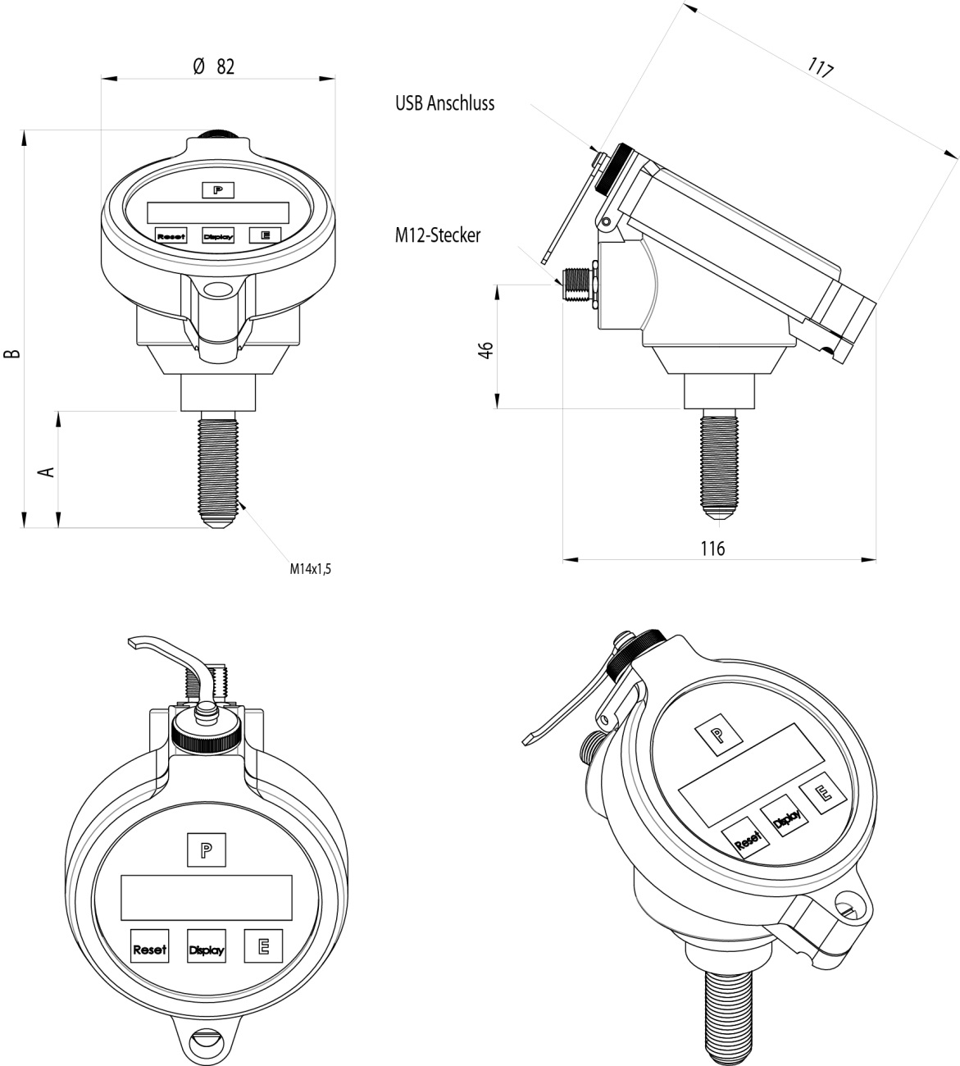

Fig. 9: Dimensional drawings VTC / VIC with connector M12

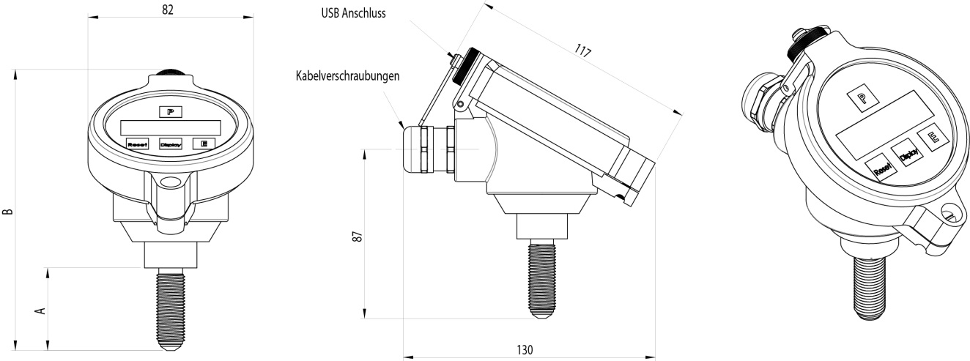

Fig. 10: Dimensional drawings VTC / VIC with screw type terminal
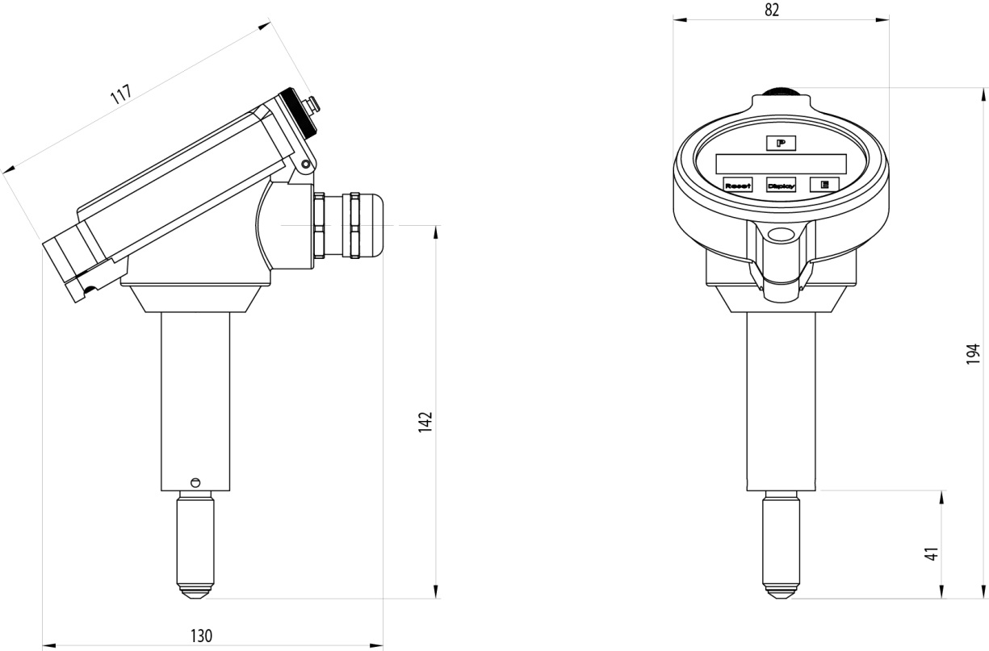
Fig. 11: Dimensional drawings VTC / VIC with screw type terminal and extra long pickup tip

WEEE and RoHS
The unit described herein is not subject to the WEEE directive and the corresponding national laws.
At the end of life forward the unit to a specialized recycling company and do not dispose it off as domestic waste.
The unit described herein fully complies with the RoHS directive.

List of figures
Fig. 1: Operating elements ront side 7
Fig. 2: Operating elemente side view 8
Fig. 3: Wiring diagram passive 4-20mA sensor 14
Fig. 4: Wiring diagram 3 wire operation with analog and frequency output, push-pull output 15
Fig. 5: Wiring diagram 3 wire operation with analog and frequency output, NAMUR output 15
Fig. 6: Digital output stage of the VTC / VIC 16
Fig. 7: Wiring diagram 3 wire active with frequency output only, push-pull output 16
Fig. 8: Wiring diagram 3 wire active with frequency output only, NAMUR output 17
Fig. 9: Dimensional drawings VTC / VIC with connector M12 46
Fig. 10: Dimensional drawings VTC / VIC with screw type terminal 47
Fig. 11: Dimensional drawings VTC / VIC with screw type terminal and extra long pickup tip 47

Addresses
Headquarter:
KEM
Küppers Elektromechanik GmbH
Liebigstraße 5
DE-85757 Karlsfeld
Deutschland
Tel.: +49 81 31/59 39 10
info@kem-kueppers.com
www.kem-kueppers.com

Copyright KEM, Subject to change without notice, ES. Rev 002-16/02/2012

