AZBIL EUROPE NV (YAMATAKE)
Bosdellestraat 120/2
B-1933 Zaventem, Belgium
VAT no. BE 0474.687.910
Phone: +32-(0)2-785 0710
Fax:+32-(0)2-785 0711
http://www.yamatake-europe.com

Contact: Regis Houllier
Phone: +33 3 22 54 83 47
Fax: +33 3 22 54 83 29
Mobile: +33 6 89 59 13 19
Email: regis.houllier@airlitec.com

Quotation-No. | Q2012RH279
Reference: | KRPC/PROC/2012/0191/RY
Date: | 20.07.2012
Vendors No. | TYC/1603/42/KD

Azbil Europe NV ● Bosdellestraat 120/2 ● B-1933 Zaventem ● Belgium
Managing Director
Kaduna Refining & Petrochemical Co. Ltd.
KM 16 Kachia Road
P.M.B. 2252
Kaduna - Nigeria

Quotation-No. Q2012RH279

Dear Sir,

Please find below our best offer and terms for supply of the requested Control Valves. The current Control Valves in this proposal are equivalent in process with the existing Complete Control Valves.

Item | Model-Code |  |  | Description |  | QT`Y | Unit | Price/Unit | Amount
 |  |  |  |  |  |  |  | [EURO] | [EURO]
1 | Model HTS Valve |  |  | Valves HTS  4“ size  ANSI300 RF  To replace ValveTag no: 16-FV-051 |  | 1 | ea | 12.868,00 | 12.868,00
 |  |  |  |  | Total Ex Works |  |  | EURO | 12.868,00
 |  |  |  |  | Packaging and Handling and Inland Transport |  |  | EURO | 1.650,00
 |  |  |  |  | Total FOB Japanease Airport |  |  | EURO | 14.518,00
 |  |  |  |  | Air Freight charge |  |  | EURO | 3.855,00
 |  |  |  |  | Total Sum C & F Lagos, Nigeria |  |  | EURO | 18.373,00
TERMS OF DELIVERY |  |  | TYC/1603/42/KD
Delivery Time: |  | 5 months Ex-factory after receipt of order and payment
Payment Terms: |  | By Letter of Credit established by a First Class European Bank or Local Purchase Order issued to our Agent; Tycol Limited
Validity: |  | Sixty (60) days from the quotation date.
Country of Origin: |  | Japan
Country of Supply: |  | Japan
Manufacturer: |  | Yamatake Corporation
Mode of dispatch: |  | C & F Murtala International Air port, Lagos, Nigeria
Shipping Information: |  | Will be informed later
Warranty Period: |  | 12 Months from the date of shipment.
End-use Statement: |  | Not required, but information on End-user and use is required upon the receipt of P.O.
Other Conditions: |  | Please see the General Terms of Conditions of Sales for other conditions than the above.
Technical: |  | See data sheet attached
In addition the Trade Terms are in accordance with Incoterms 2000 and the general trade terms of Yamatake Europe N.V. are valid. – Please request them if needed.

With best regards
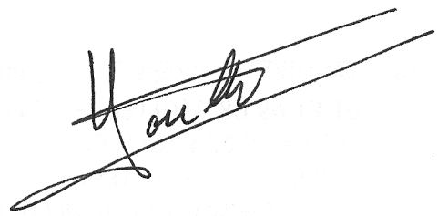

Regis Houllier
On behalf of Azbil Europe NV

