AZBIL EUROPE NV (YAMATAKE)
Bosdellestraat 120/2
B-1933 Zaventem, Belgium
VAT no. BE 0474.687.910
Phone: +32-(0)2-785 0710
Fax:+32-(0)2-785 0711
http://www.yamatake-europe.com

Contact: Regis Houllier
Phone: +33 3 22 54 83 47
Fax: +33 3 22 54 83 29
Mobile: +33 6 89 59 13 19
Email: regis.houllier@airlitec.com

Quotation-No. | Q2012RH162
Reference: | KRPC/PROC/2012/0840/UP
Date: | 17.08.2012
Vendors No. | TYC/1603/38/KD

Azbil Europe NV ● Bosdellestraat 120/2 ● B-1933 Zaventem ● Belgium
Managing Director
Kaduna Refining & Petrochemical Co. Ltd.
KM 16 Kachia Road
P.M.B. 2252
Kaduna - Nigeria

Quotation-No. Q2012RH162

Dear Sir,

Please find below our best offer and terms for supply of the requested Differential Pressure Transmitter (Smart).

Item | Model-Code |  |  | Description |  | QT`Y | Unit | Price/Unit | Amount
 |  |  |  |  |  |  |  | [EURO] | [EURO]
1 | Model GTX31D-  AF1AXA1-R1 |  |  | DP Cell Transmitter  Span: 0 – 2500mm H20  Output Hart: 4-20mA  Process connection: Rc1/4 with adapter Top  Wetted parts: Stainless Steel  With FM explosion proof approvam  With Indicator  With CF8 mounting bracket  With custom calibration |  | 12 | ea | 1.240,00 | 14.880,00
2 | Model GTX31D -AA1XXA1-R1 |  |  | DP Cell Transmitter  Range: 0-100Kpas  Output: 4-20mA  Wetted parts: Stainless Steel  Process connection: ½ NPT with adapter  Process installation: Horizong piping  With mounting bracket  With custom calibration |  | 5 | ea | 1,100,00 | 5.500,00
 |  |  |  |  | Total Ex Works |  |  | EURO | 20.380,00
 |  |  |  |  | Packaging and Handling and Inland Transport |  |  | EURO | 1.650,00
 |  |  |  |  | Total FOB Japanease Airport |  |  | EURO | 22.030,00
 |  |  |  |  | Air Freight charge |  |  | EURO | 5.850,00
 |  |  |  |  | Total Sum C & F Lagos, Nigeria |  |  | EURO | 27.880,00
TERMS OF DELIVERY |  |  | TYC/1603/38/KD
Delivery Time: |  | 10 weeks Ex-factory after receipt of order and payment
Payment Terms: |  | By Letter of Credit established by a First Class European Bank or Local Purchase Order issued to our Agent; Tycol Limited
Validity: |  | Sixty (60) days from the quotation date.
Country of Origin: |  | Japan
Country of Supply: |  | Japan
Manufacturer: |  | Yamatake Corporation
Mode of dispatch: |  | C & F Murtala International Air port, Lagos, Nigeria
Shipping Information: |  | Will be informed later
Warranty Period: |  | 12 Months from the date of shipment.
End-use Statement: |  | Not required, but information on End-user and use is required upon the receipt of P.O.
Other Conditions: |  | Please see the General Terms of Conditions of Sales for other conditions than the above.
Technical: |  | See data sheet attached
In addition the Trade Terms are in accordance with Incoterms 2000 and the general trade terms of Yamatake Europe N.V. are valid. – Please request them if needed.
With best regards
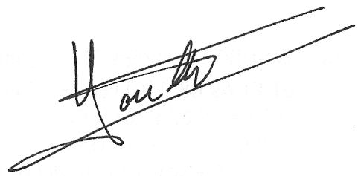Regis Houllier (On behalf of Azbil Europe NV)

