AZBIL EUROPE NV (YAMATAKE)
Bosdellestraat 120/2
B-1933 Zaventem, Belgium
VAT no. BE 0474.687.910
Phone: +32-(0)2-785 0710
Fax:+32-(0)2-785 0711
http://www.yamatake-europe.com

Contact: Regis Houllier
Phone: +33 3 22 54 83 47
Fax: +33 3 22 54 83 29
Mobile: +33 6 89 59 13 19
Email: regis.houllier@airlitec.com

Quotation-No. | Q2012RH069
Reference:
Date: | 22.02.2012
Vendors No. | TYC/1603/32/AVS

Azbil Europe NV ● Bosdellestraat 120/2 ● B-1933 Zaventem ● Belgium
Avsco Houston Int’l Operation Nig. Ltd
54 Emekuku Street,
D – Line, Port Harcourt,
Rivers State.
Nigeria.

Attn: Olamide Durodolu

Quotation-No. Q2012RH069

Dear Sir,

Please find below our best offer and terms for supply of the requested smart field communicator. The current smart field communicator in this proposal is equivalent in process with the existing smart field communicator.

Item | Model-Code |  |  | Description |  | QT`Y | Unit | Price/Unit | Amount
 |  |  |  |  |  |  |  | [EURO] | [EURO]
1 | Model CFS100-U1-X |  |  | Smart Field Communicator;  Software and Adapter (with USB adapter) |  | 2 | ea | 1.650,00 | 3.300,00
 |  |  |  |  | Total Ex Works |  |  | EURO | 3.300,00
 |  |  |  |  | Packaging and Handling and Inland Transport |  |  | EURO | 360,00
 |  |  |  |  | Total FOB Japanease Airport |  |  | EURO | 3.660,00
 |  |  |  |  | Air Freight charge |  |  | EURO | 1,380,00
 |  |  |  |  | Total Sum C & F Lagos, Nigeria |  |  | EURO | 5.040,00
TERMS OF DELIVERY |  |  | TYC/1603/32/AVS
Delivery Time: |  | 6 weeks Ex-factory after receipt of order and payment
Payment Terms: |  | By Local Purchase Order issued to our Agent; Tycol Limited
Validity: |  | Sixty (60) days from the quotation date.
Country of Origin: |  | Japan
Country of Supply: |  | Japan
Manufacturer: |  | Yamatake Corporation
Mode of dispatch: |  | C & F Murtala International Air port, Lagos, Nigeria
Shipping Information: |  | Will be informed later
Warranty Period: |  | 12 Months from the date of shipment.
End-use Statement: |  | Not required, but information on End-user and use is required upon the receipt of P.O.
Other Conditions: |  | Please see the General Terms of Conditions of Sales for other conditions than the above.
Technical: |  | See data sheet attached
In addition the Trade Terms are in accordance with Incoterms 2000 and the general trade terms of Yamatake Europe N.V. are valid. – Please request them if needed.

With best regards

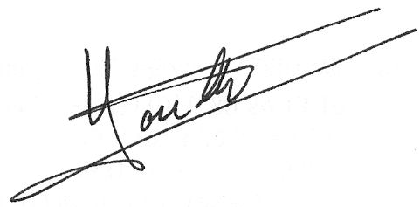
Regis Houllier
On behalf of Azbil Europe NV

