AZBIL EUROPE NV (YAMATAKE)
Bosdellestraat 120/2
B-1933 Zaventem, Belgium
VAT no. BE 0474.687.910
Phone: +32-(0)2-785 0710
Fax:+32-(0)2-785 0711
http://www.yamatake-europe.com

Contact: Regis Houllier
Phone: +33 3 22 54 83 47
Fax: +33 3 22 54 83 29
Mobile: +33 6 89 59 13 19
Email: regis.houllier@airlitec.com

Quotation-No. | Q2011RH0377/02
Reference: | ETSD
Date: | 02.02.2012
Vendors No. | TYC/1603/28/KD/B

Azbil Europe NV ● Bosdellestraat 120/2 ● B-1933 Zaventem ● Belgium
Managing Director
Kaduna Refining & Petrochemical Co. Ltd.
KM 16 Kachia Road
P.M.B. 2252
Kaduna - Nigeria

Quotation-No. Q2011RH0377/02

Dear Sir,

Please find below our best offer and terms for supply of the requested Seat Ring in Viton. The Seat Ring is for your valve 16PV008.

 | Item | Model-Code |  |  | New Model/Old Production No. |  | QT`Y | Unit | Price/Unit | Amount
 |  |  |  |  |  |  |  |  | [EURO] | [EURO]
 | 1 | Seat Ring |  |  | Rubber Seat for 16PV008 Valve  (Viton, SS400 Insert) |  | 2 | ea | 5.878,00 | 11.756,00
 |  |  |  |  |  | Total Ex Works |  |  | EURO | 11.756,00
 |  |  |  |  |  | Packaging and Handling and Inland Transport |  |  | EURO | 850,00
 |  |  |  |  |  | Total FOB Japanese Airport |  |  | EURO | 12.606,00
 |  |  |  |  |  | Air Freight charge |  |  | EURO | 1,850,00
 |  |  |  |  |  | Total Sum C & F Lagos Airport, Nigeria |  |  | EURO | 14.456,00
TERMS OF DELIVERY |  |  |  | TYC/1603/28/KD/B
Delivery Time: |  |  | 30th of April, 2012
Payment Terms: |  |  | By Letter of Credit established by a First Class European Bank or Local Purchase Order issued to our Agent; Tycol Limited
Validity: |  |  | Sixty (60) days from the quotation date.
Country of Origin: |  |  | Japan
Country of Supply: |  |  | Japan
Manufacturer: |  |  | Yamatake Corporation
Mode of dispatch: |  |  | C & F Murtala International Air port, Lagos, Nigeria
Shipping Information: |  |  | Will be informed later
Warranty Period: |  |  | 12 Months from the date of shipment.
End-use Statement: |  |  | Not required, but information on End-user and use is required upon the receipt of P.O.
Other Conditions: |  |  | Please see the General Terms of Conditions of Sales for other conditions than the above.
Technical: |  |  | See data sheet attached
In addition the Trade Terms are in accordance with Incoterms 2000 and the general trade terms of Yamatake Europe N.V. are valid. – Please request them if needed.

With best regards
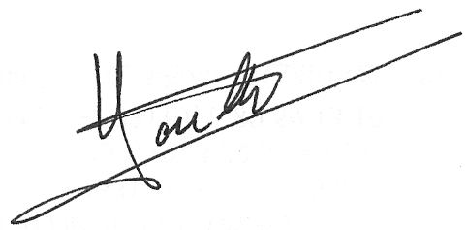

Regis Houllier
On behalf of azbil Europe NV

