AZBIL EUROPE NV (YAMATAKE)
Bosdellestraat 120/2
B-1933 Zaventem, Belgium
VAT no. BE 0474.687.910
Phone: +32-(0)2-785 0710
Fax:+32-(0)2-785 0711
http://www.yamatake-europe.com

Contact: Regis Houllier
Phone: +33 3 22 54 83 47
Fax: +33 3 22 54 83 29
Mobile: +33 6 89 59 13 19
Email: regis.houllier@airlitec.com

Quotation-No. | Q2011RH0203 Rev 1
Reference: | KRPC/PROC/2011/0534/SB
Date: | 18.08.2012
Vendors No. | TYC/1603/22/KD

Azbil Europe NV ● Bosdellestraat 120/2 ● B-1933 Zaventem ● Belgium
Managing Director
Kaduna Refining & Petrochemical Co. Ltd.,
Km 16 Kachia Road,
P. M. B. 2252,
Kaduna,
Nigeria

Quotation-No. Q2011RH0203 Rev 1

Dear Sir,

Please find below our best offer and terms for supply of the requested Positioners for fuel plant.

 | Item | Model-Code |  |  | Description | QT`Y | Unit | Price/Unit | Amount
 |  |  |  |  |  |  |  | [EURO] | [EURO]
 | 1 | AVP300-FSD1B-1XXX-X |  |  | AVP Positioner  FM explosionproof  Air piping: 1/4NPT  Positioner: 130 to 150Kpas  Gauge: in Kgf/cm2  With filter and pressure requlator  Without Mounting Bracket | 10 | ea | 1.395,00 | 13.950,00
 | 2 | HTP-ASM1NP1LKDX  80250300-211DX |  |  | HTP Positioner | 30 | ea | 1.180,00 | 35.400,00
 |  |  |  |  | Total Ex Works |  |  | EURO | 49.350,00
 |  |  |  |  | Packaging and Handling and Inland Transport |  |  | EURO | 2.150,00
 |  |  |  |  | Total FOB Japanese Seaport |  |  | EURO | 51.500,00
 |  |  |  |  | Air Freight charge |  |  | EURO | 4.850,00
 |  |  |  |  | Total Sum C & F Lagos |  |  | EURO | 56.350,00
TERMS OF DELIVERY |  |  |  | TYC/1603/22/KD
Delivery Time: |  |  | 16 weeks Ex-factory after receipt of order and payment
Payment Terms: |  |  | Confirmed Irrevocable Letter of Credit from acceptable European Bank in favour of Azbil Europe NV
Validity: |  |  | Sixty (60) days from the quotation date.
Country of Origin: |  |  | Japan
Country of Supply: |  |  | Japan
Manufacturer: |  |  | Yamatake Corporation
Mode of dispatch: |  |  | C & F Murtala International Air port, Lagos, Nigeria
Shipping Information: |  |  | Will be informed later
Warranty Period: |  |  | 12 Months from the date of shipment.
End-use Statement: |  |  | Not required, but information on End-user and use is required upon the receipt of P.O.
Other Conditions: |  |  | Please see the General Terms of Conditions of Sales for other conditions than the above.
Technical: |  |  | See data sheet attached
In addition the Trade Terms are in accordance with Incoterms 2000 and the general trade terms of Yamatake Europe N.V. are valid. – Please request them if needed.

With best regards

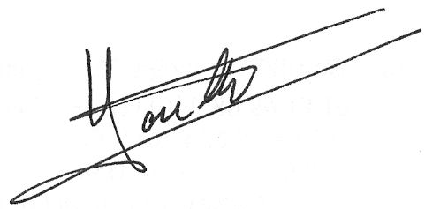

Regis Houllier (On behalf of Azbil Europe NV)

