AZBIL EUROPE NV
Bosdellestraat 120/2
B-1933 Zaventem, Belgium
VAT no. BE 0474.687.910
Phone: +32-(0)2-785 0710
Fax:+32-(0)2-785 0711
http://www.yamatake-europe.com

Contact: Mr. Regis Houllier
Phone: +33 3 22 54 83 47
Fax: +33 3 22 54 83 29
Email: r.houllier.ly@eu.azbil.com
Web: htt://eu.azbil.com

Quotation-No. | Q2010RH0407
Reference: | KRPC/PROC/2011/0152/SB
Date: | 08.12.2011
Vendors No. | TYC/1603/16/KD

azbil Europe NV ● Bosdellestraat 120/2 ● B-1933 Zaventem ● Belgium
Managing Director,
Kaduna Refining and Petrochemical Company Limited
Km 16 Kachia Road
Kaduna
Nigeria

Attn: Engr. B. Ayodele,

QUOTATION - No. Q2010RH0407

Please find below our best offer and terms for supply of the requested HTP Positioner.
Item | Model | Description | QT`Y | Unit | Price/Unit | Amount
 |  |  |  |  | [EURO] | [EURO]
1. | HTP-1D | HTP Positioner with Gauge | 120 | ea | 1,360.00 | 163,200.00
 |  | HTP-ASN1NNILKRX
 |  | 8025030N-111RX
 |  | Total Exworks |  |  | EURO | 163,200.00
 |  | Packaging and Handling and Inland Transport |  |  | EURO | 2,850,00
 |  | Total FOB Japanease Airport |  |  | EURO | 166,050.00
 |  | Air Freight charge |  |  | EURO | 13,500,00
 |  | Total Sum C & F Lagos Int’l Airport |  |  | EURO | 179,550.00

REMARKS: Tyc/1603/16/KD
* Lead time may be changed depending on the condition of the outstanding orders at our factory side
* For our export procedure, End User Name + Country + End Use (company‘s main activity, product) must be
specified on your purchase Order Sheet.
* Before shipping the goods please take notice that the payment must be registered in our Bank account.

TERMS and CONDITIONS
Trade Terms: | FCA JAPAN / Direct shipment from Japan by Air (Freight collect) by our forwarder,
 | Unless otherwise instructed on your order sheet
Payment Terms: | By Letter of Credit or Through our Agent Tycol Limited
Country of Origin : | Japan
Country of Supply : | Japan
Delivery: | 12 weeks Ex-factory after receipt of order and payment
Minimum Order Amount : | Euro 150 per order (Packing & Handling and Freight charges excluded).
Partial Shipment: | Not allowed.
Shipping Route: | By Air freight
Validity: | 60 days from quotation date.
Cancellation: | Not allowed after your order is acknowledged.

(The Trade Terms are in accordance with lncoterms 2000.)

Regis Houllier
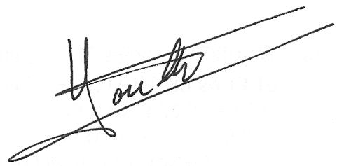
On behalf of Azbil Europe N. V.

