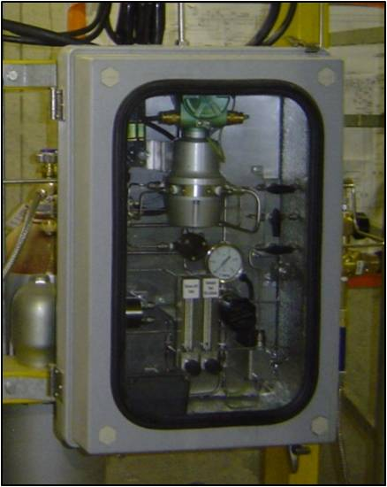

ONLINE GAS ANALYZER
Technical Description

December’2008

TABLE OF CONTENTS
1 INTRODUCTION 3
2 HGC303 - TECHNICAL DESCRIPTION 4
3 HGC303 – DESCRIPTION OF MEASUREMENTS 5
3.1 Measured Values 5
3.2 Calculated Values 5
4 HGC303 – SAMPLE PROBES & FLOW CONDITIONERS 6
4.1 Sample probe with liquid eliminator and pressure regulator 6
4.2 Sample regulator 7
4.3 Flow conditioner 7
5 HGC303 – ONLINE ANALYZER SCHEMATIC 7
6 HGC303 – SPECIFICATIONS 8
7 QA & HSE 9
8 CONTACT INFORMATION 9

INTRODUCTION
The model HGC303 is the world smallest gas chromatograph, which is capable of analyzing 11 different components of natural gas and digitally publishing the derived parameters, such as calorific value, Wobbe-index, molecular weight, compressibility and density.
The model HGC303 fulfils the requirements of Norsok I-SR-106 for on-line gas chromatography. The HGC303 analysis and calculations complies with international standards: ISO 6974, 6976 and GPA 2145, 2172. 2261.
The main advantages compared to similar products are:
- Simplified installation
- Reduced space requirements
- Reduced cost

HGC303 - TECHNICAL DESCRIPTION
Acoustic Reservoir Pressure Surveillance involves shooting an acoustic pulse from surface down the tubing. Since the acoustic velocity varies with the gas density in the gas filled section of the tubing, the gradient of the gas column can be calculated using one/multiple
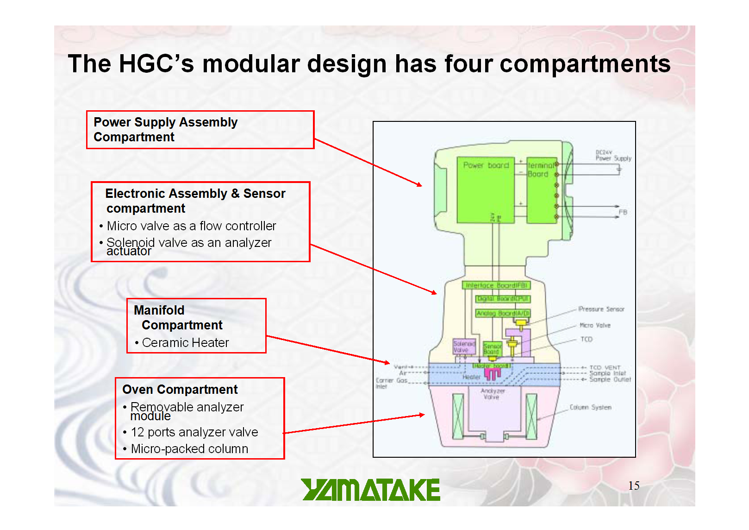
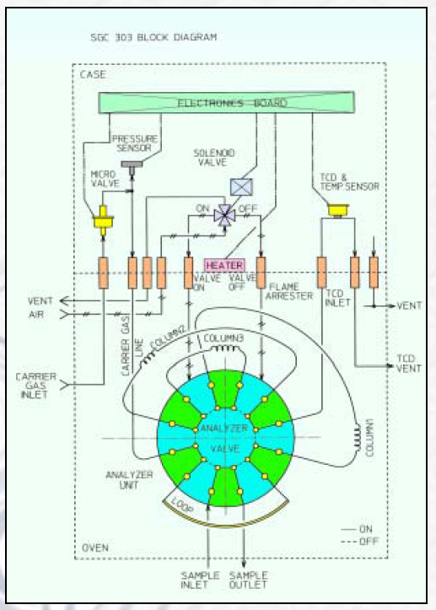

HGC303 – DESCRIPTION OF MEASUREMENTS

Measured Values
The table below describes the different components quantified by the HGC303 Gas Analyzer:

Calculated Values
The table below describes values calculated by the HGC303 according to international API standards:

HGC303 – SAMPLE PROBES & FLOW CONDITIONERS

Sample probe with liquid eliminator and pressure regulator
For applications where a sample probe is required in order to obtain a representative sample. Max. pressure: 100 bar, Material: SS-316, Probe connection ½” NPT, Input/Output/Auxillary connection: ¼” NPT (Other options available).

Sample regulator
Used for applications where a probe is not required. Maximum pressure: 5000psi, Material: SS-316, Input/Output/Auxillary connection: ¼” NPT (Other options available).

Flow conditioner
The flow conditioner is the best way to protect the HGC303 from liquid and particles causing damage to the analyzer. The unit combines a 25 micron filter with a floating ball that is visible to the operator. Max. pressure: 100 bar, Sample inlet/outlet/ drain connections: ¼ “ NPT connection, Meterial: SS-316.
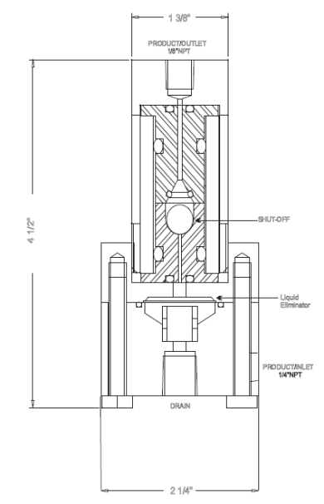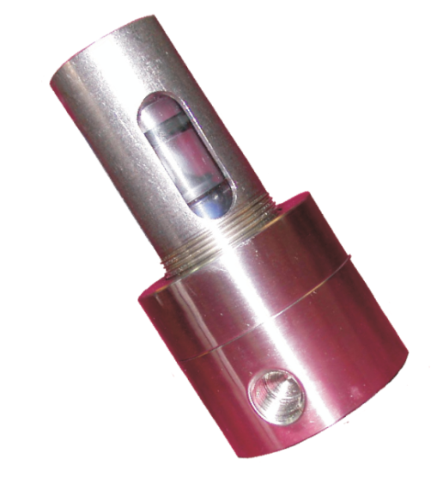

HGC303 – ONLINE ANALYZER SCHEMATIC
MV (optional)
PI
PI
PI
Process Gas / Gas Inlet
Calibration Gas
Carrier Gas & Valve Gas
Flow Conditioner
– Particle & Liquid removal
Flow Regulator (3 l/h)
Gas Outlet
TCD Vent
HGC303
Valve Vent

HGC303 – SPECIFICATIONS

QA & HSE
Our QA & HSE documentation is certified by DnV in accordance with the
ISO 9001:2000 standard.


ScanWell A.S is an approved supplier of offshore products & services listed in the Achilles database:

CONTACT INFORMATION

ScanWell - Offshore Base

